Brief of UML : inheritance : triangle symbol(towards base class : read as “derived from”), composition (has a) diamond symbol (food is contained in fridge : symbol towards fridge).  
Dependent class has dotted line.

A simple arrow pointing from one class to another represents an association. This indicates a relationship between the two classes.

A dashed arrow towards a class indicates a dependency relationship. Dependency implies that a change in one class may affect another class.

A filled diamond-shaped arrow towards a class represents a composition relationship. Composition is a stronger form of aggregation, where the parts are strongly bound to the whole, and the lifetime of the parts is dependent on the whole.

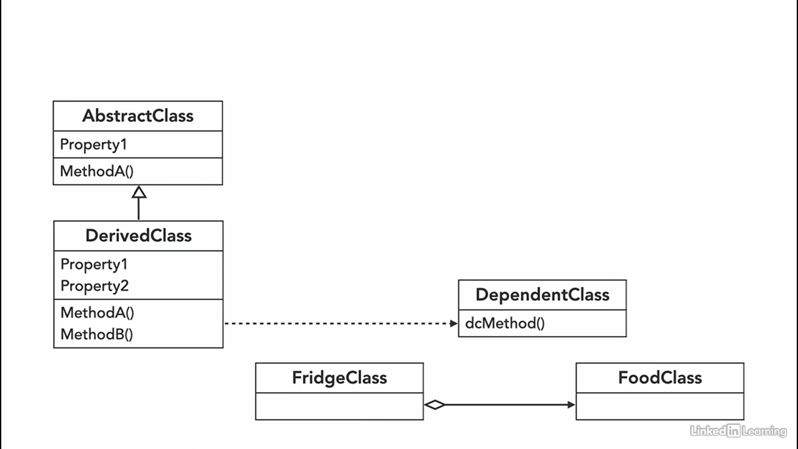

-The code of the same pattern applied to two different programs may be different.

-On the other hand, a pattern is more like a blueprint: you can see what the result and its features are, but the exact order of implementation is up to you.

**-Unjustified use of knowing a single design pattern :**

If all you have is a hammer, everything looks like a nail.

-The most basic and low-level patterns are often called *idioms*. They usually apply only to a single programming language.

-The most universal and high-level patterns are *architectural patterns*. Developers can implement these patterns in virtually any language. Unlike other patterns, they can be used to design the architecture of an entire application.

* **Creational patterns** provide object creation mechanisms that increase flexibility and reuse of existing code.
* **Structural patterns** explain how to assemble objects and classes into larger structures, while keeping these structures flexible and efficient.
* **Behavioral patterns** take care of effective communication and the assignment of responsibilities between objects.

creational :

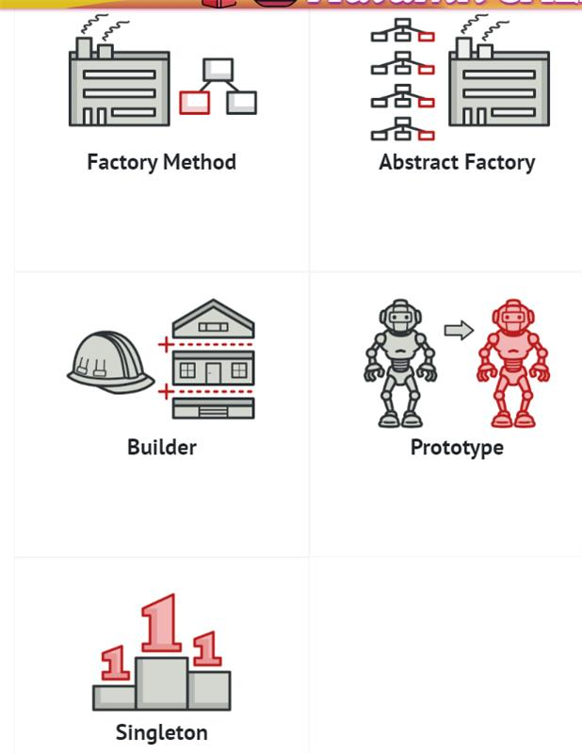

structural :

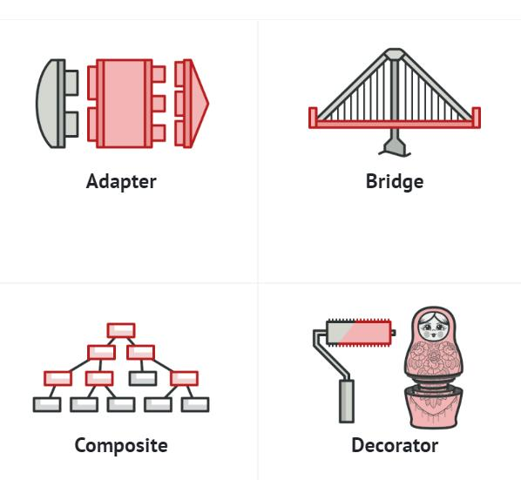

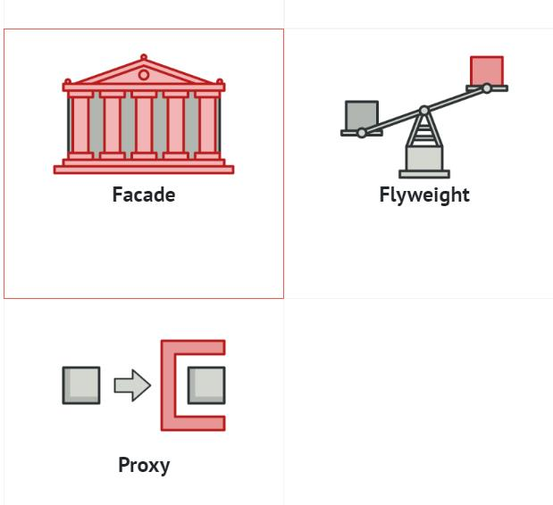

Behavioural :

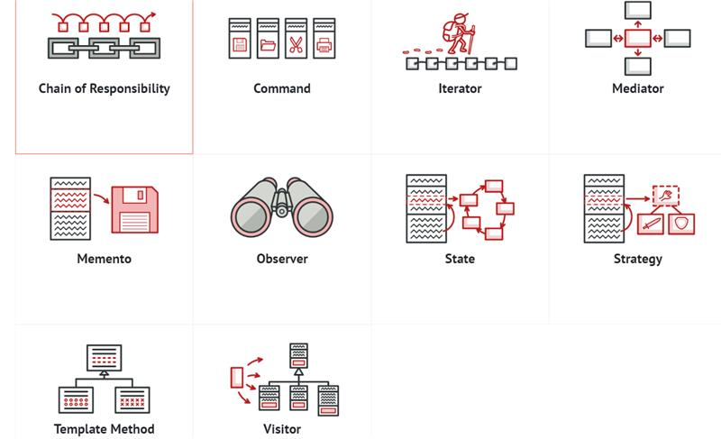

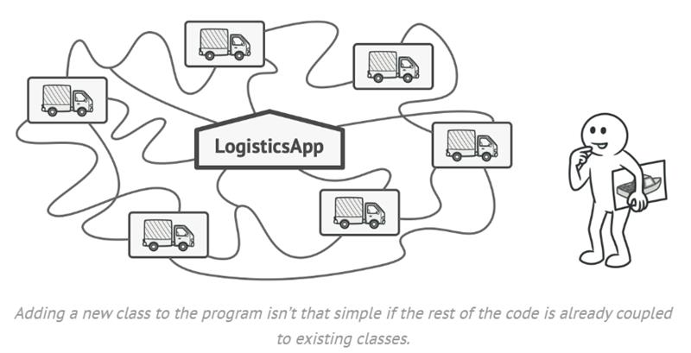

The Factory Method pattern suggests that you replace direct object construction calls (using the new operator) with calls to a special *factory* method. Don’t worry: the objects are still created via the new operator, but it’s being called from within the factory method. Objects returned by a factory method are often referred to as *products.*

At first glance, this change may look pointless: we just moved the constructor call from one part of the program to another. However, consider this: now you can override the factory method in a subclass and change the class of products being created by the method.

Disadvantage of deriving classes (Inheritance) for every variation:

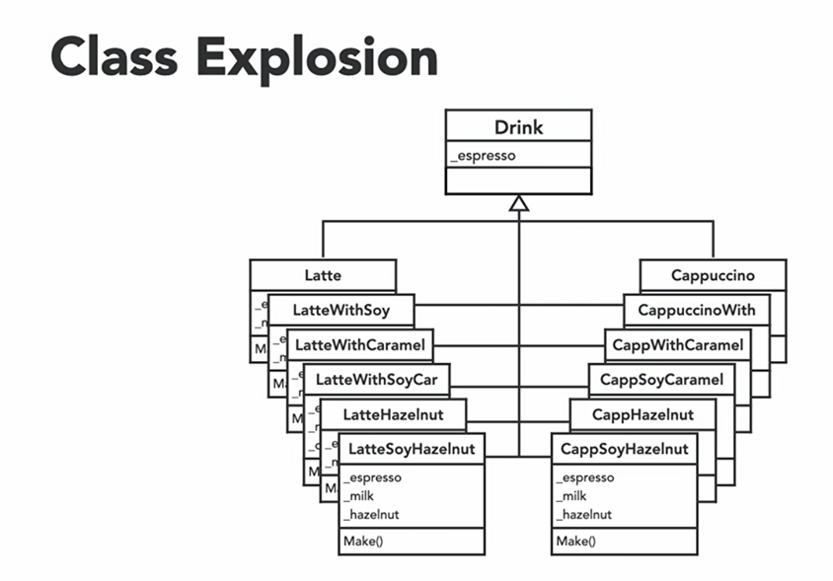

Solution to this problem is to use composition along with Inheritance.

if there's a virtual method in base class, that function must be overridden in all derived classes, otherwise we'll get a compiler error.

The base class of virtual methods is called abstract class and derived classes are called concrete classes.

Factory method : There’s a slight limitation though: subclasses may return different types of products only if these products have a common base class or interface. Also, the factory method in the base class should have its return type declared as this interface.

The Creator class declares the factory method that returns new product objects. It’s important that the return type of this method matches the product interface.

Concrete Creators override the base factory method so it returns a different type of product.

Note that the factory method doesn’t have to create new instances all the time. It can also return existing objects from a cache, an object pool, or another source.

Note that, despite its name, the creator's primary responsibility isn't creating products. It usually contains some core business logic that relies on product objects returned by the factory method. Subclasses can indirectly change that business logic by overriding the factory method and returning a different type of product from it.

* **Use the Factory Method when you don’t know beforehand the exact types and dependencies of the objects your code should work with.**

The Factory Method separates product construction code from the code that actually uses the product. Therefore it’s easier to extend the product construction code independently from the rest of the code.

For example, to add a new product type to the app, you’ll only need to create a new creator subclass and override the factory method in it.

* **Use the Factory Method when you want to provide users of your library or framework with a way to extend its internal components.**
* **Use the Factory Method when you want to save system resources by reusing existing objects instead of rebuilding them each time.**

Probably the most obvious and convenient place where this code could be placed is the constructor of the class whose objects we’re trying to reuse. However, a constructor must always return **new objects** by definition. It can’t return existing instances.

Factory Method : coffee machine example :  
  
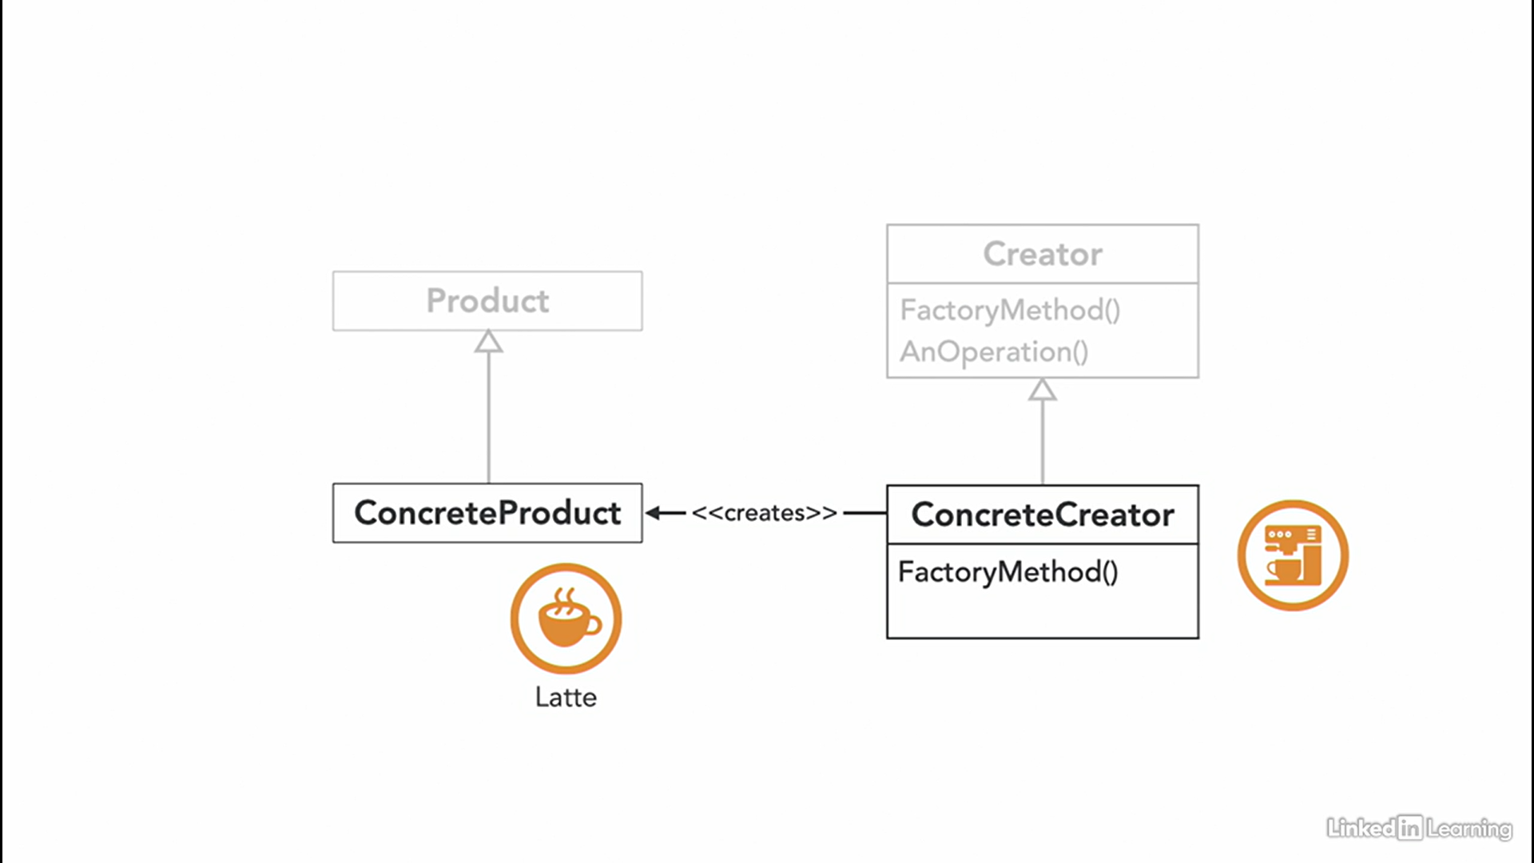

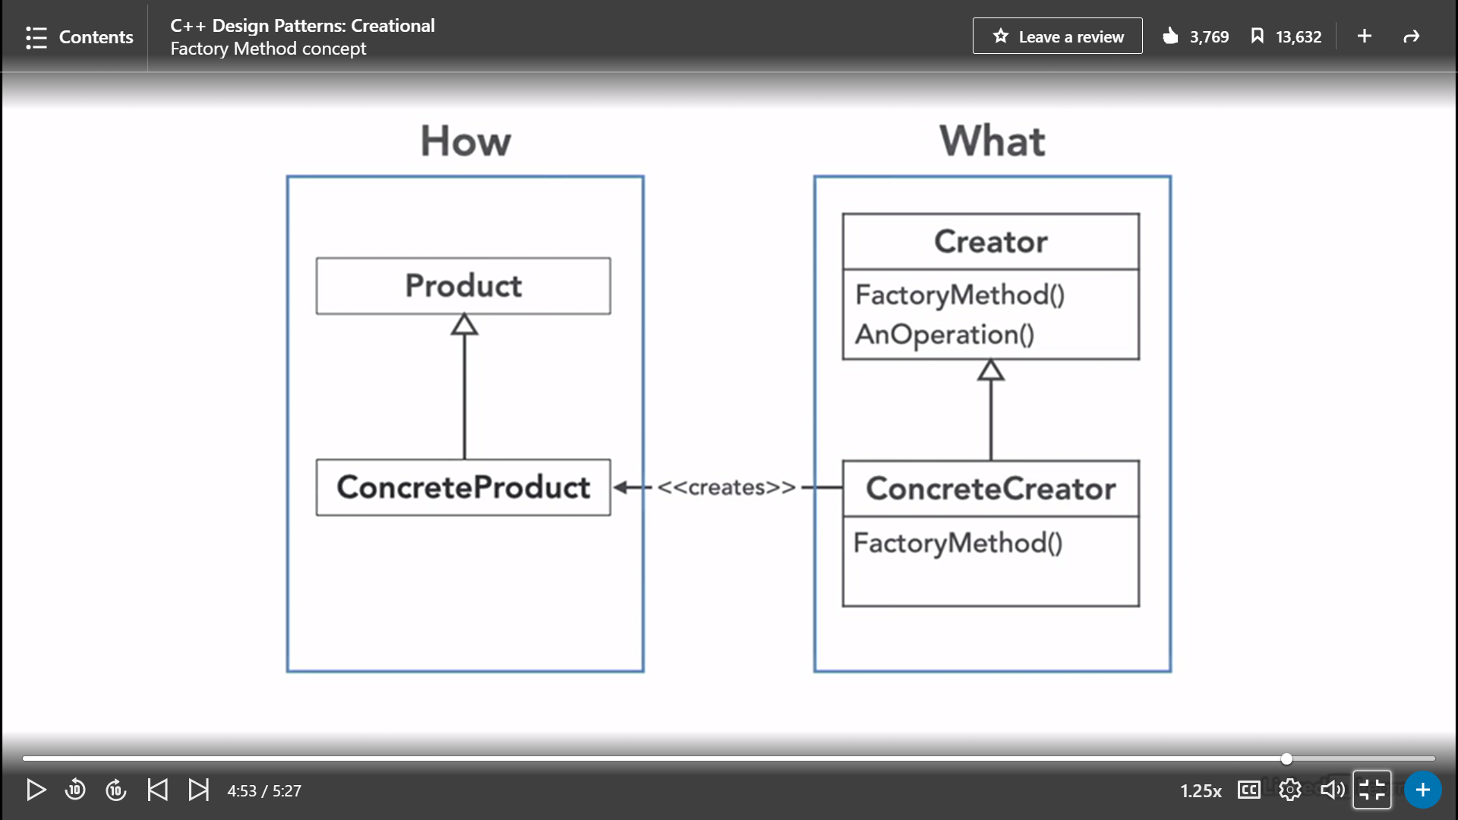

Factory method implementation:

1. U can either ask in the constructor from user, which kind of object it wants to create.
2. Or u can make constructor as private, and force the user to call one of the public functions of the class to create object of their choice. The public functions will be using the private constructor internally.

Friend class mechanism violates open close principle, not advisable to be used. Only a friend class can access private members of a class.

ABSTRACT FACTORY METHOD:  
it is a factory method for a set of objects having similar characteristics. It can be considered as a factory of factories.

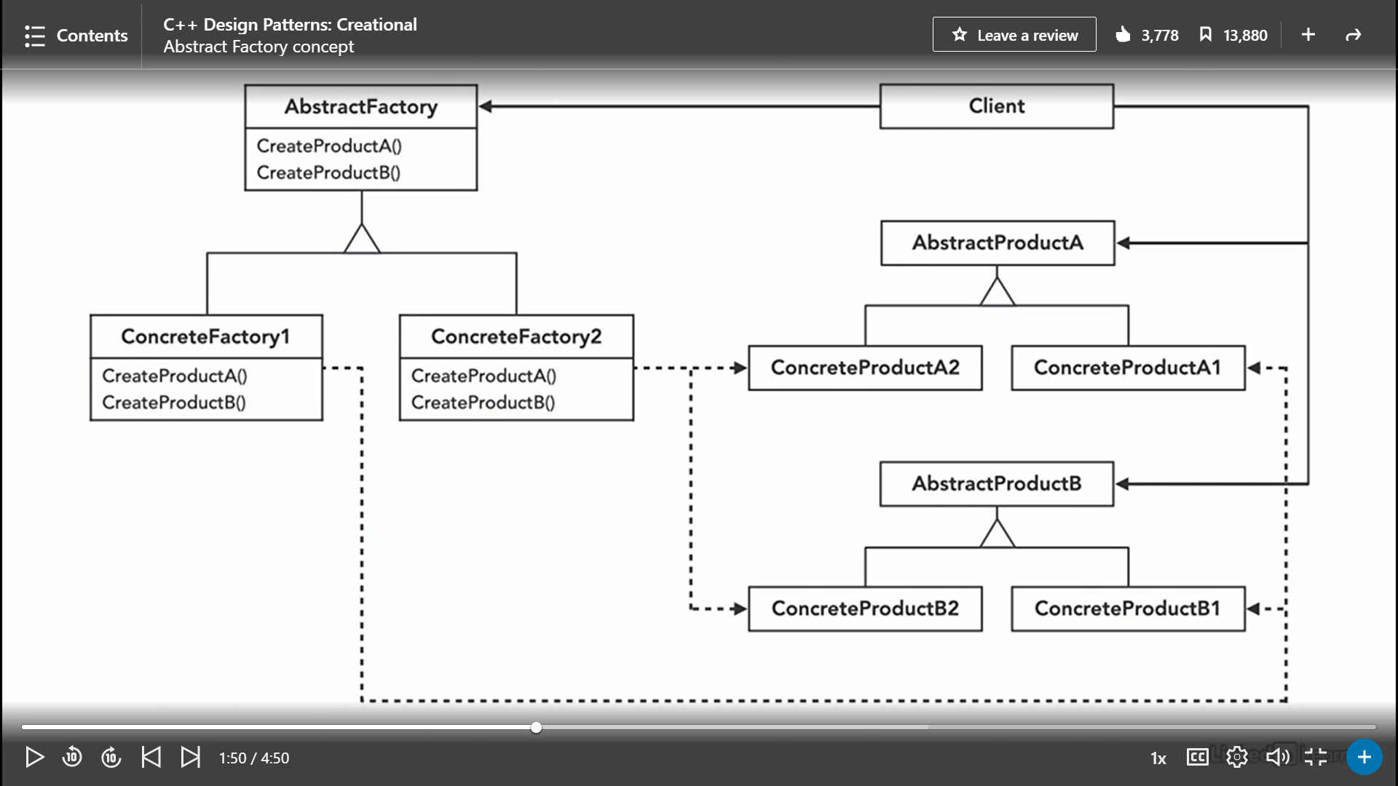

Example : we have a car factory that produces battery powered cars and fuel powered cars, although both have similar parts like doors and engines , yet they are different for each category. So we have an abstract factory car that creates a battery type car and fuel powered cars as concrete products.

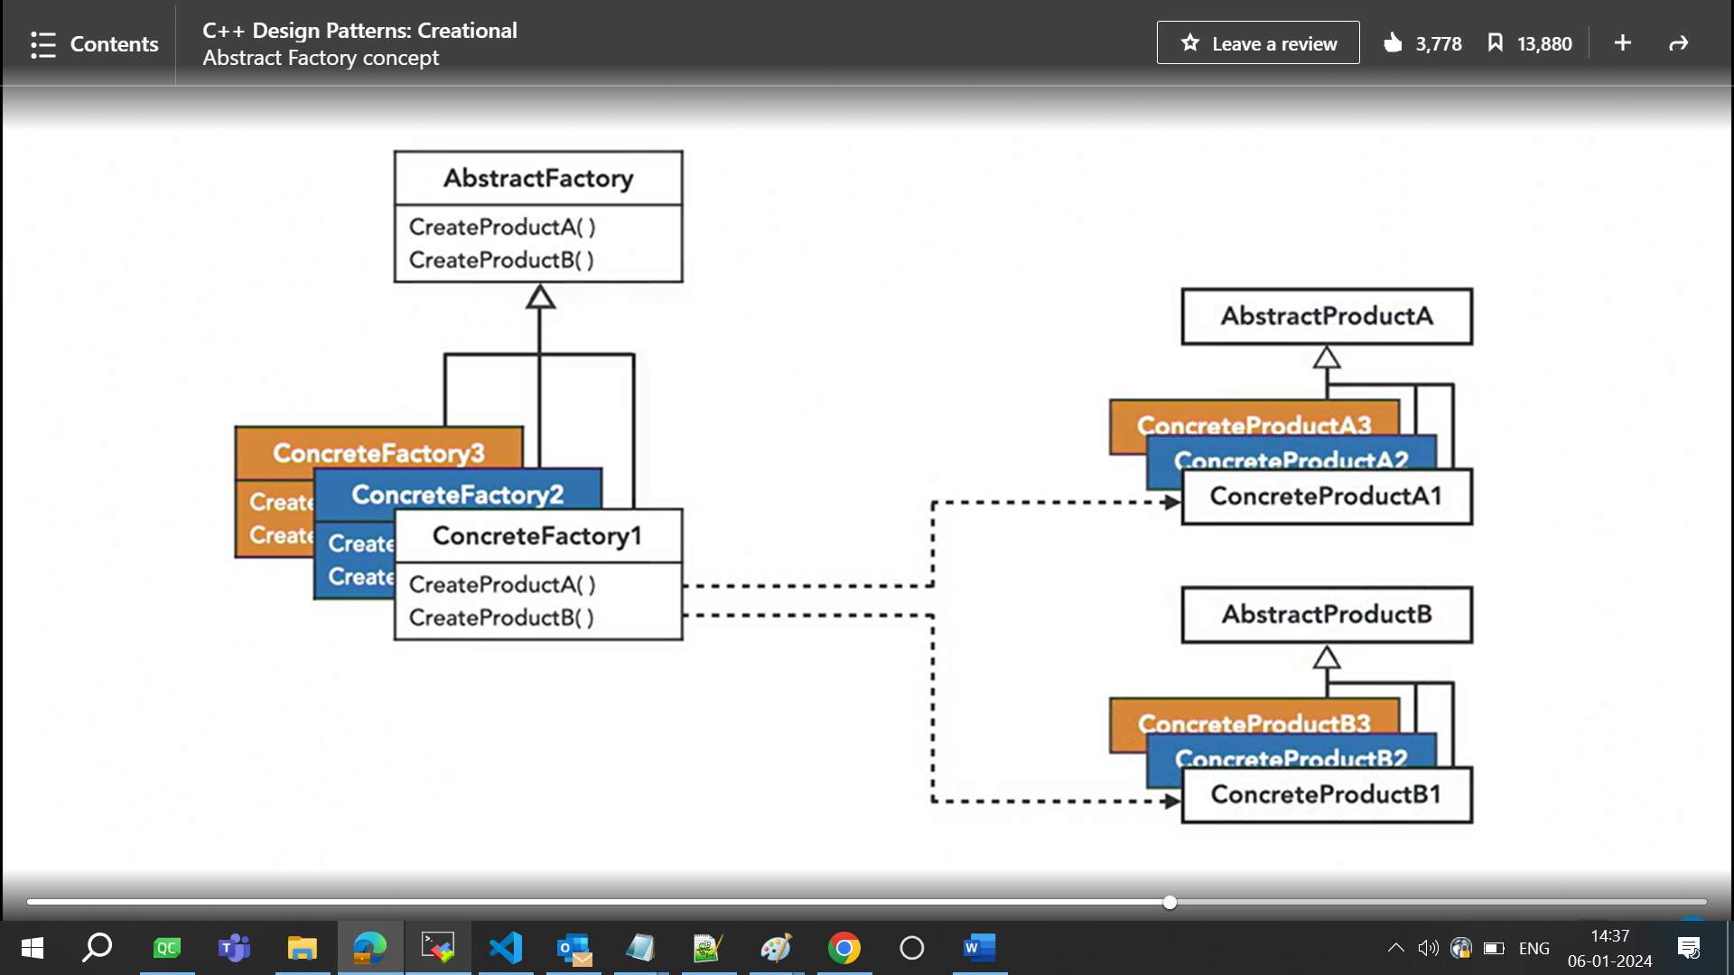

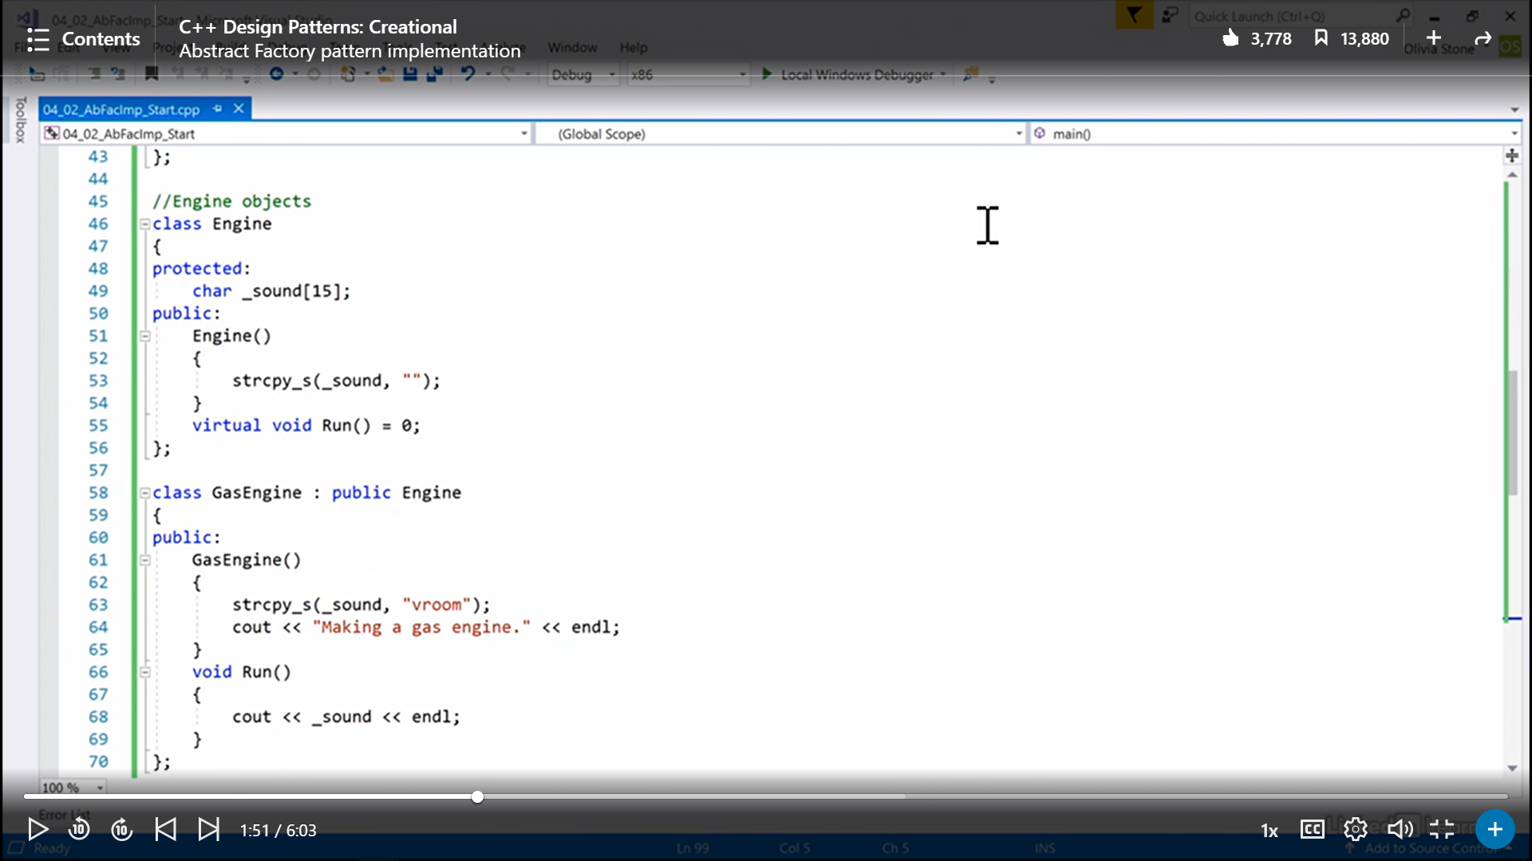

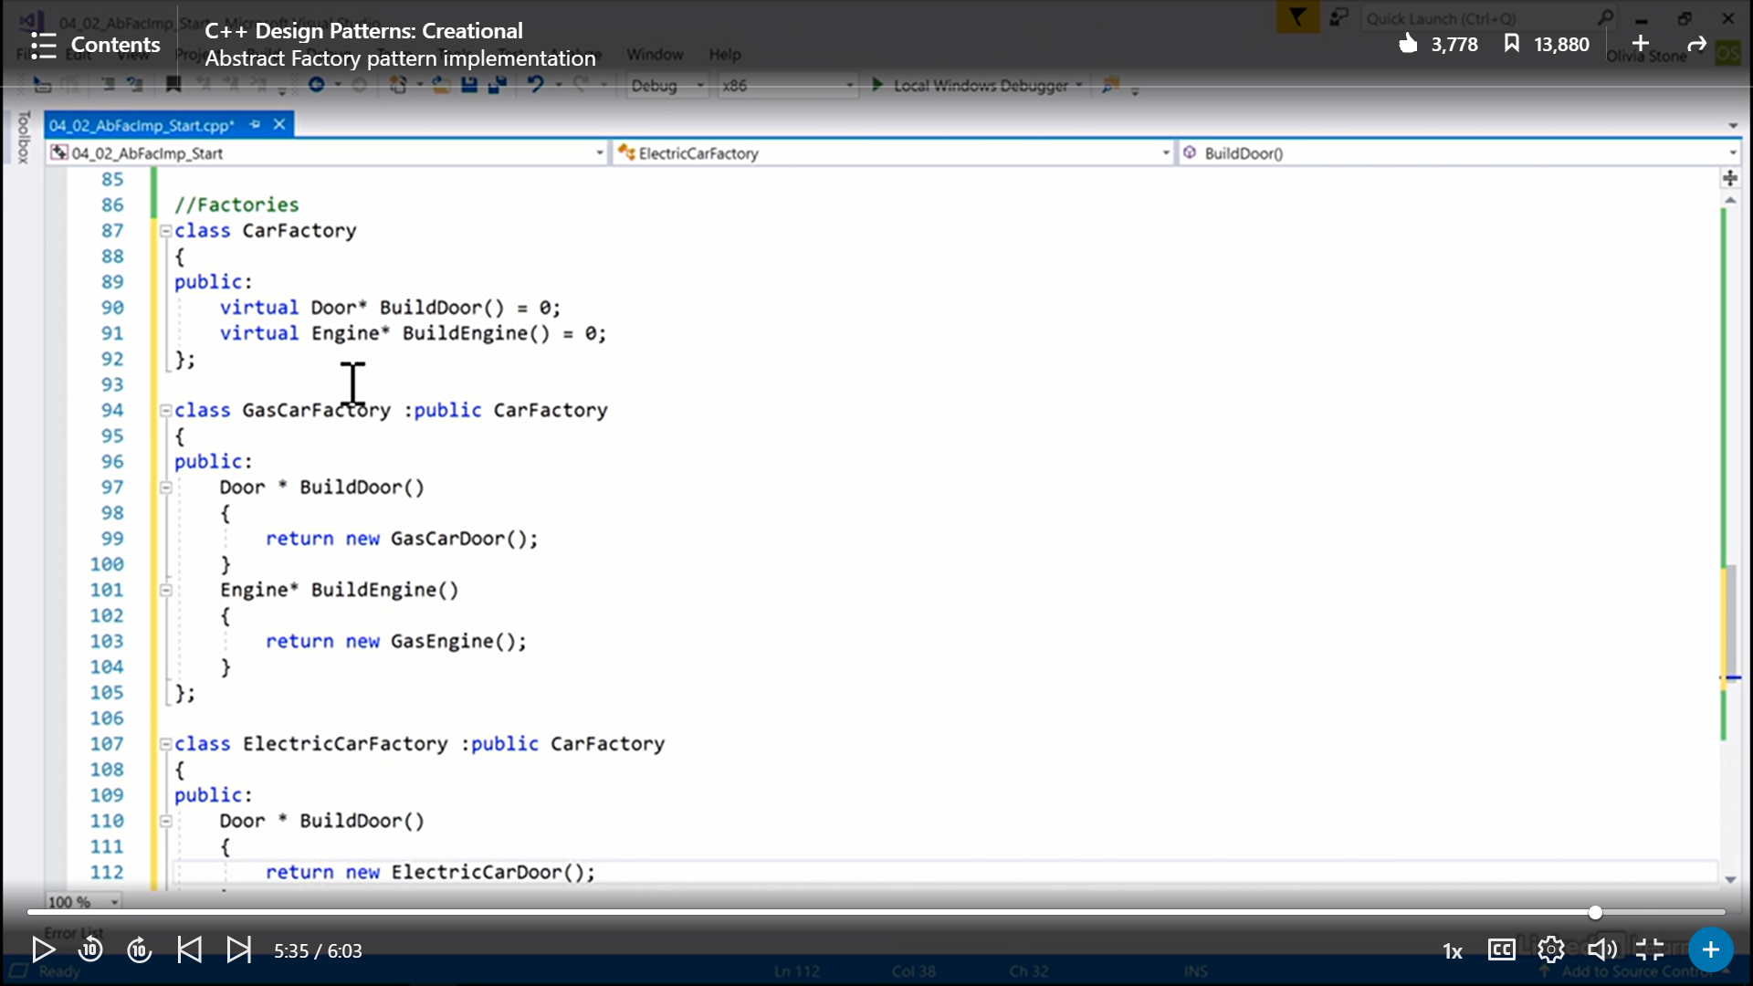

Inside main() :  
  
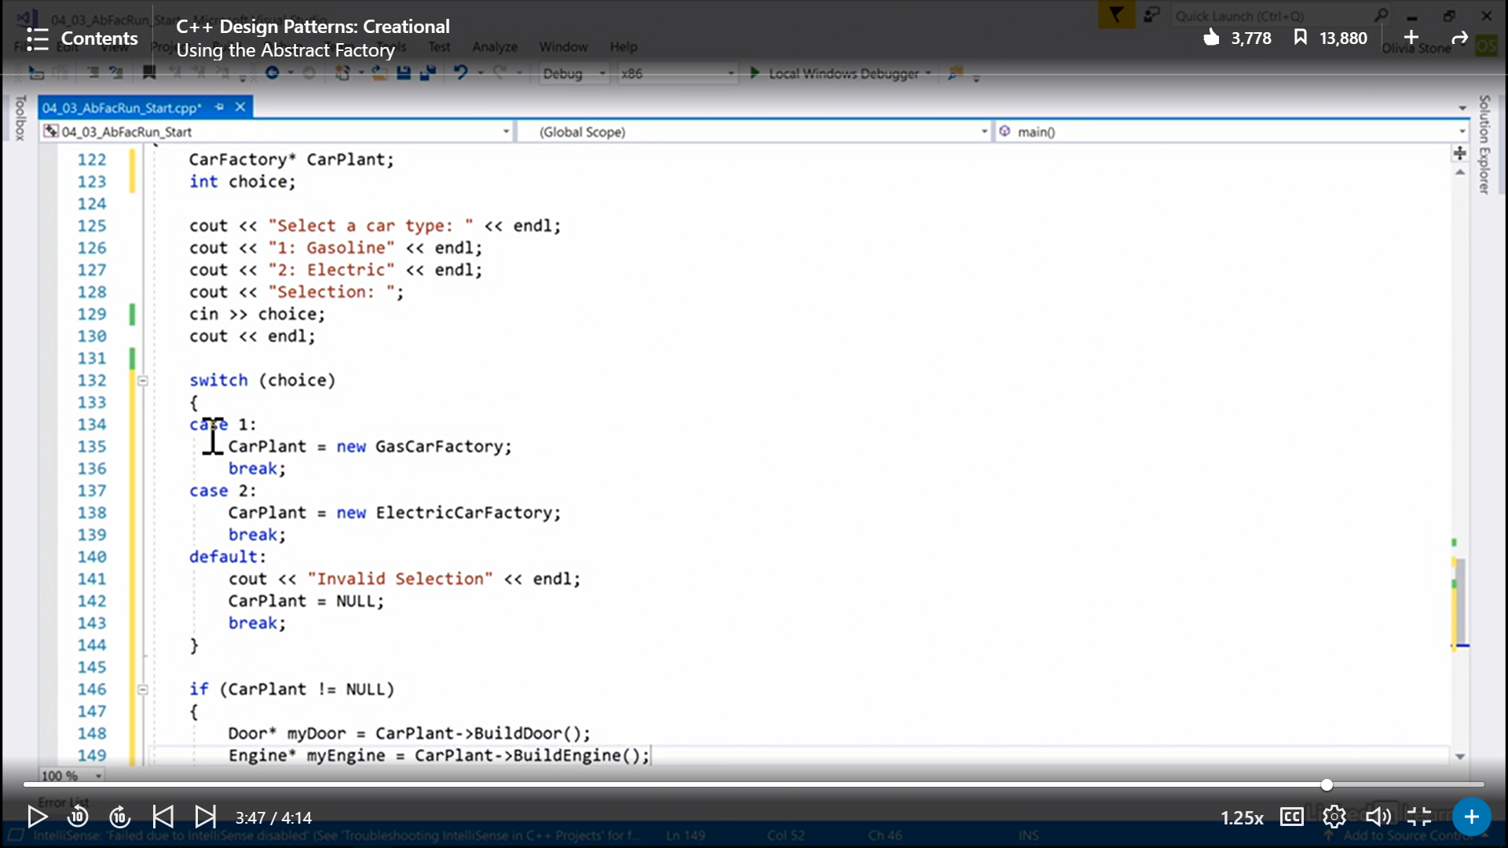

Abstract Factories keep families of objects together. Another example: light and dark theme in IDEs, light color text on dark background and vice versa.  
  
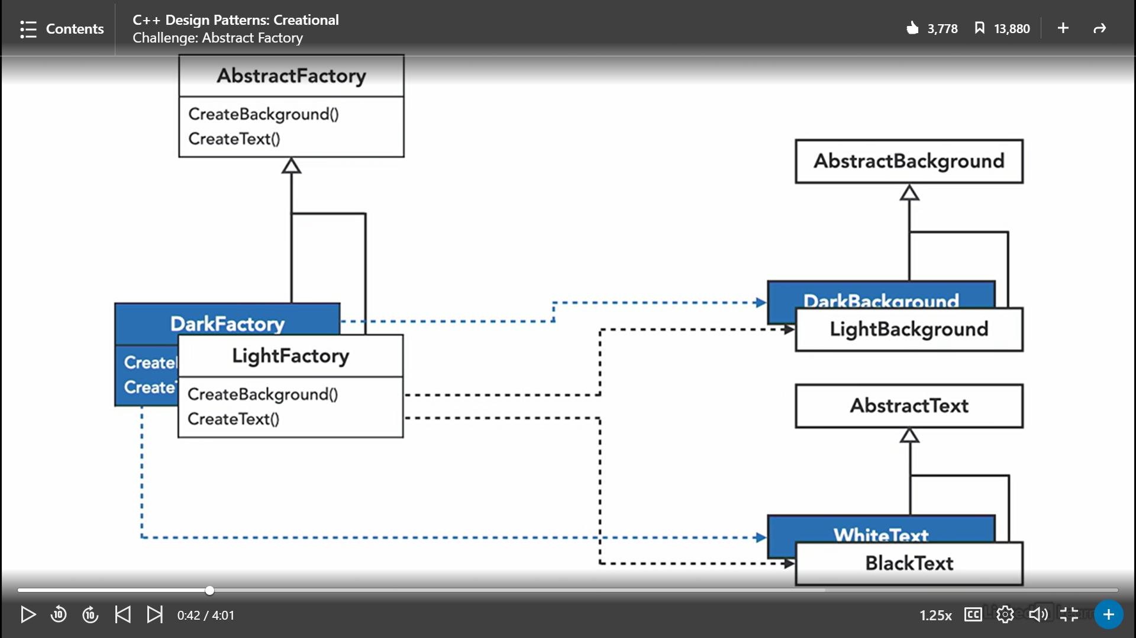

Exercise : done in qt project abstractFactory  
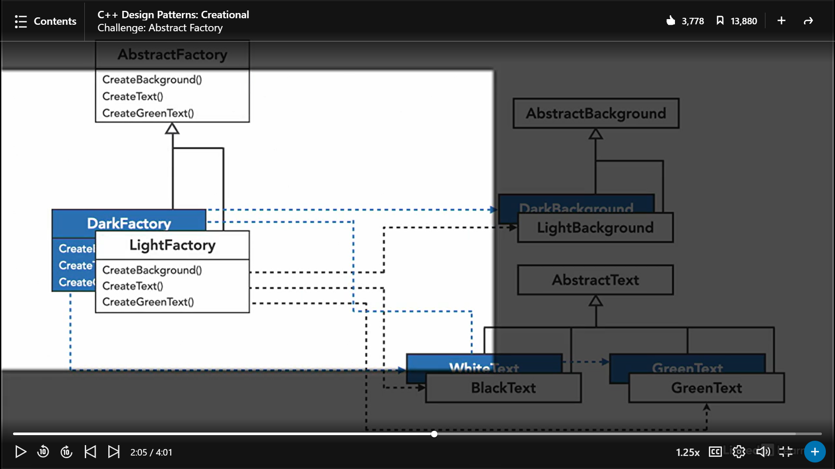  
  
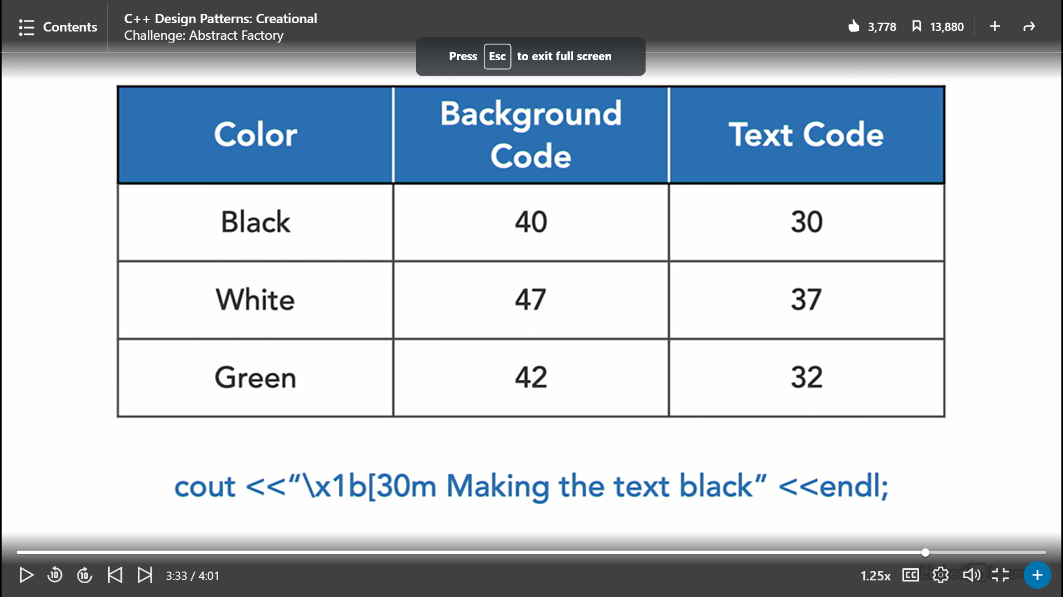

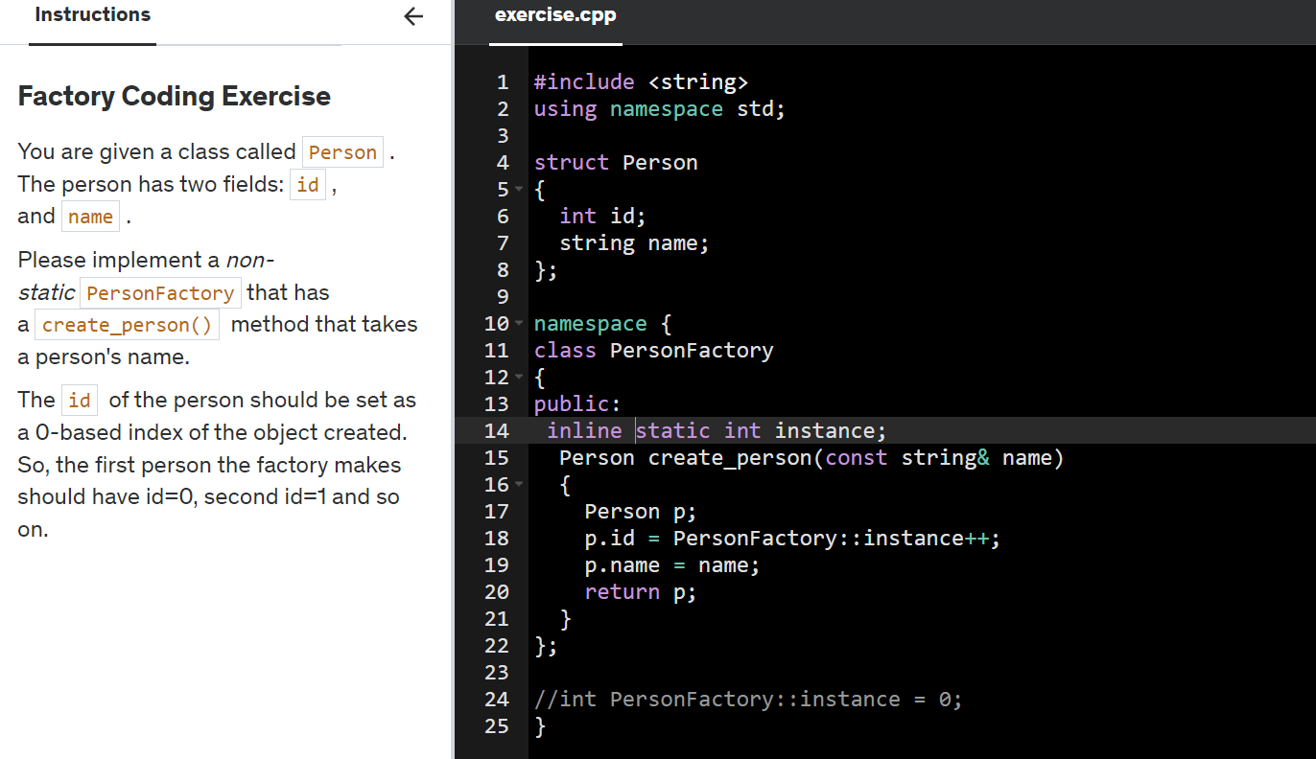

Abstract factory intent : You need a way to create individual furniture objects so that they match other objects of the same family.

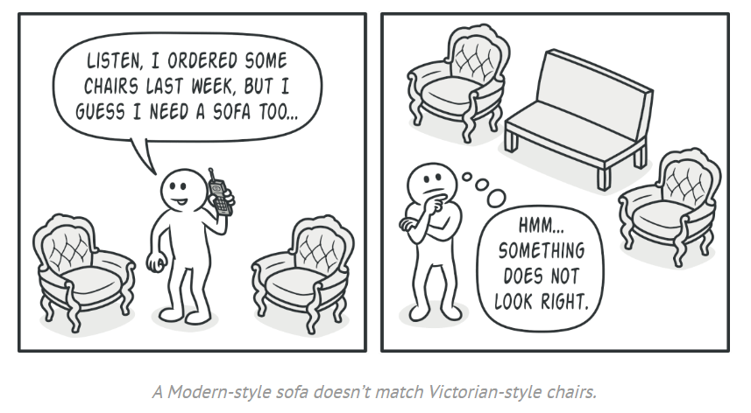

Also, you don’t want to change existing code when adding new products or families of products to the program.

The first thing the Abstract Factory pattern suggests is to explicitly declare interfaces for each distinct product of the product family (e.g., chair, sofa or coffee table). For example, all chair variants can implement the Chair interface; all coffee table variants can implement the CoffeeTable interface, and so on.

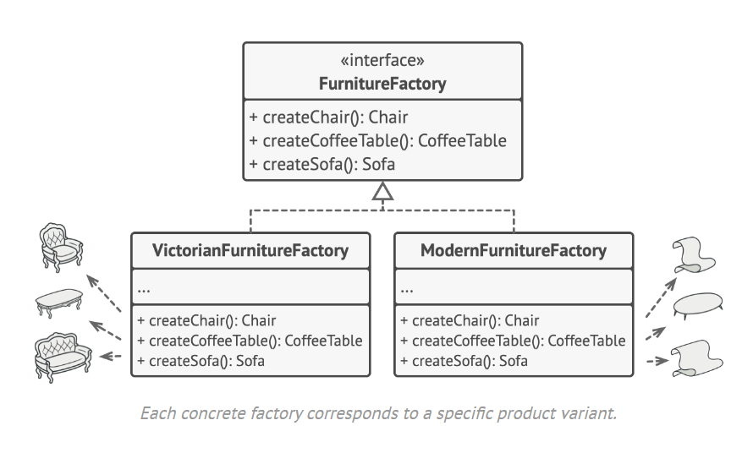

**Concrete Products** are various implementations of abstract products, grouped by variants. Each abstract product (chair/sofa) must be implemented in all given variants (Victorian/Modern).

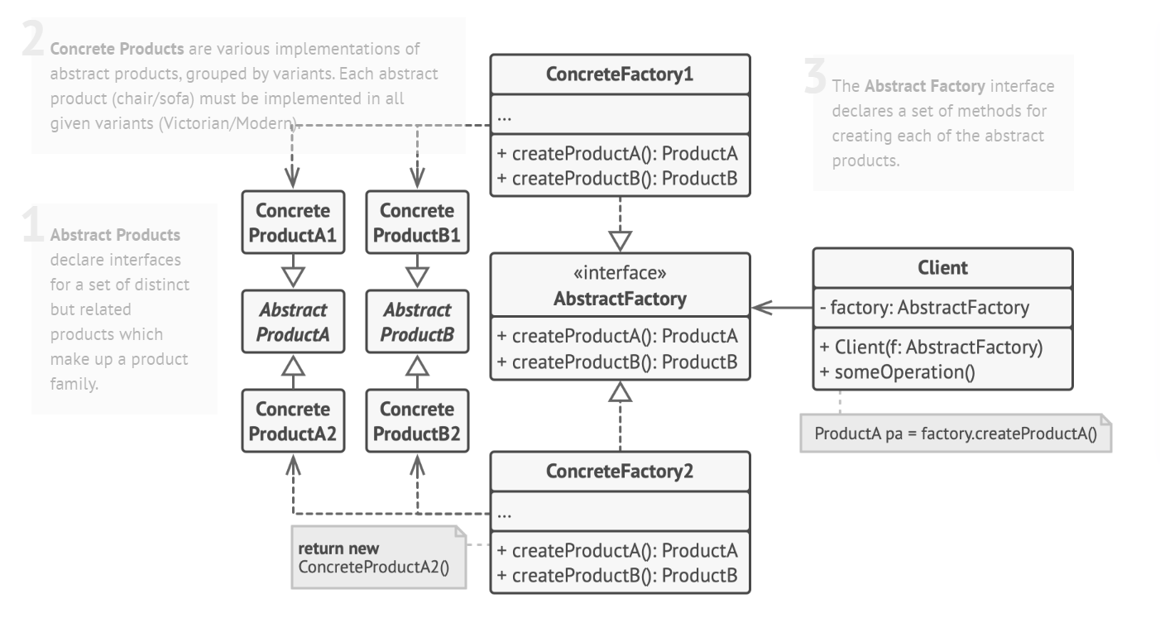

Although concrete factories instantiate concrete products, signatures of their creation methods must return corresponding *abstract* products. This way the client code that uses a factory doesn’t get coupled to the specific variant of the product it gets from a factory. The **Client** can work with any concrete factory/product variant, as long as it communicates with their objects via abstract interfaces.

## Applicability:

* **Use the Abstract Factory when your code needs to work with various families of related products, but you don’t want it to depend on the concrete classes of those products—they might be unknown beforehand or you simply want to allow for future extensibility.**
* **Consider implementing the Abstract Factory when you have a class with a set of**[**Factory Methods**](https://refactoring.guru/design-patterns/factory-method)**that blur its primary responsibility.**

## How to Implement:

1. Map out a matrix of distinct product types versus variants of these products.
2. Declare abstract product interfaces for all product types. Then make all concrete product classes implement these interfaces.
3. Declare the abstract factory interface with a set of creation methods for all abstract products.
4. Implement a set of concrete factory classes, one for each product variant.
5. Create factory initialization code somewhere in the app. It should instantiate one of the concrete factory classes, depending on the application configuration or the current environment. Pass this factory object to all classes that construct products.
6. Scan through the code and find all direct calls to product constructors. Replace them with calls to the appropriate creation method on the factory object.

* Many designs start by using [**Factory Method**](https://refactoring.guru/design-patterns/factory-method) (less complicated and more customizable via subclasses) and evolve toward [**Abstract Factory**](https://refactoring.guru/design-patterns/abstract-factory), [**Prototype**](https://refactoring.guru/design-patterns/prototype), or [**Builder**](https://refactoring.guru/design-patterns/builder) (more flexible, but more complicated).
* [**Builder**](https://refactoring.guru/design-patterns/builder) focuses on constructing complex objects step by step. [**Abstract Factory**](https://refactoring.guru/design-patterns/abstract-factory) specializes in creating families of related objects. Abstract Factory returns the product immediately, whereas Builder lets you run some additional construction steps before fetching the product.

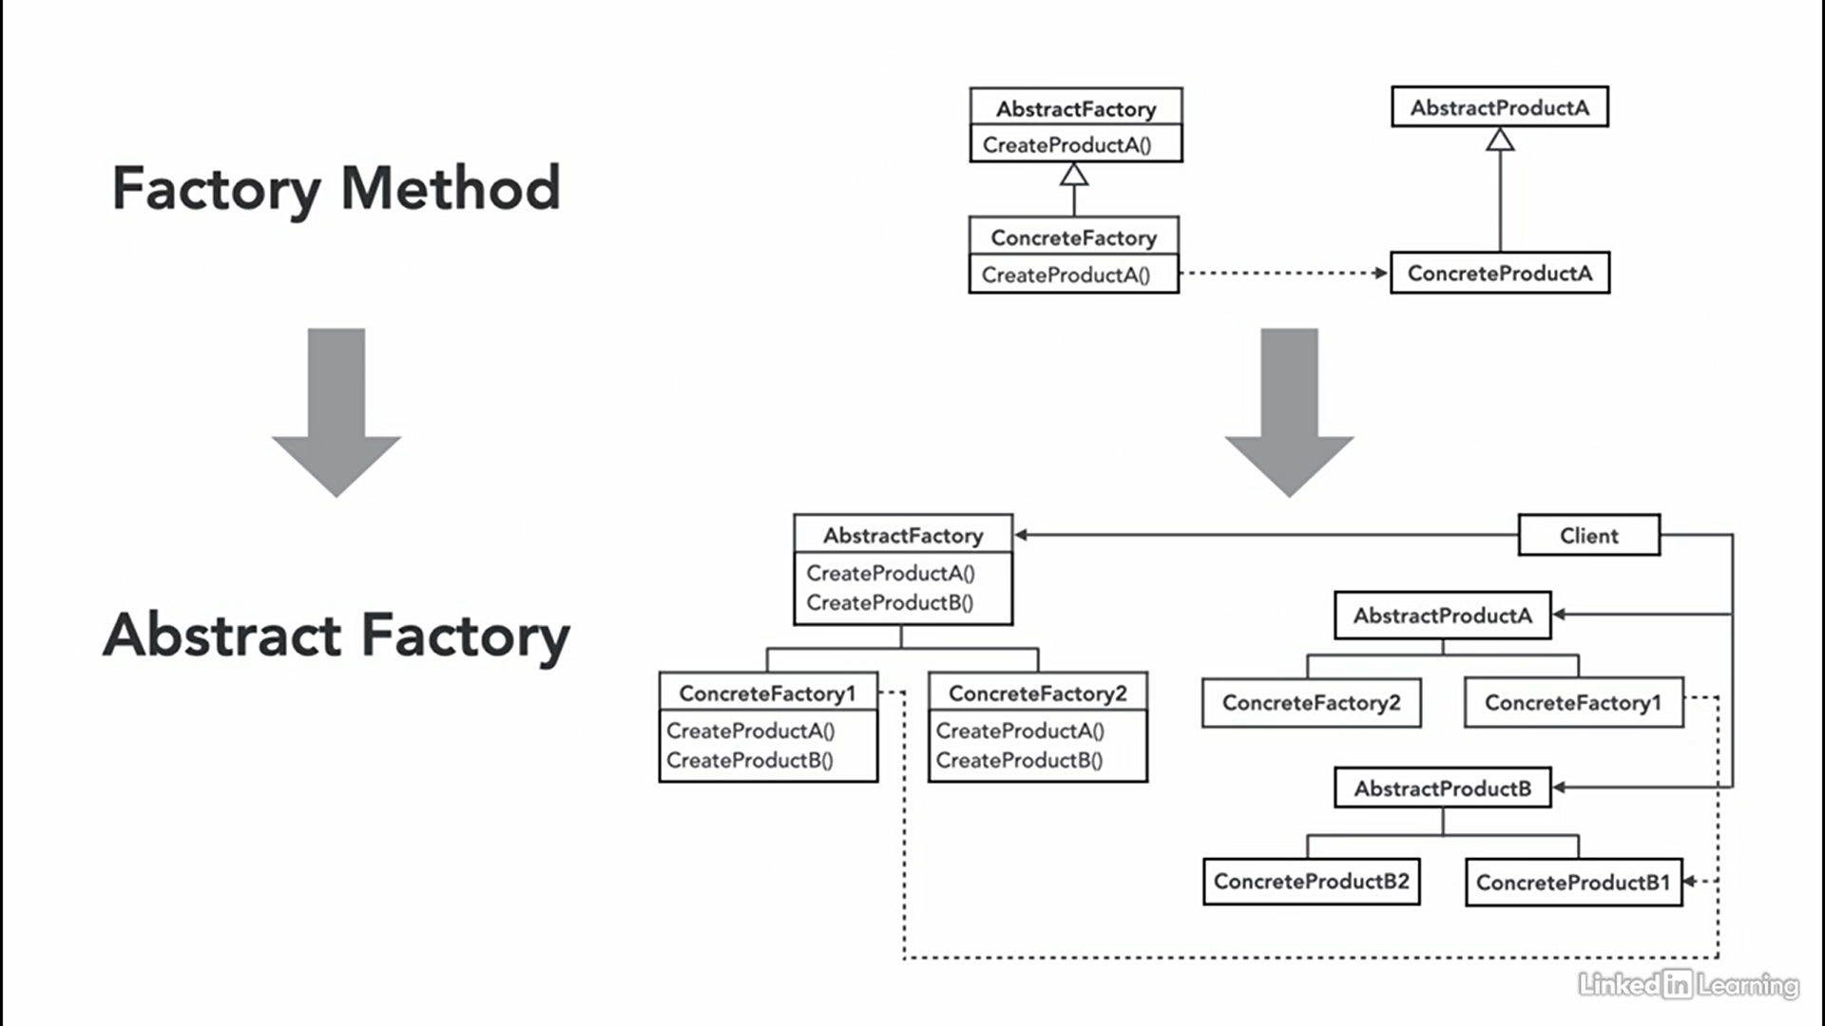

Builder design pattern: it encapsulates the build.  
  
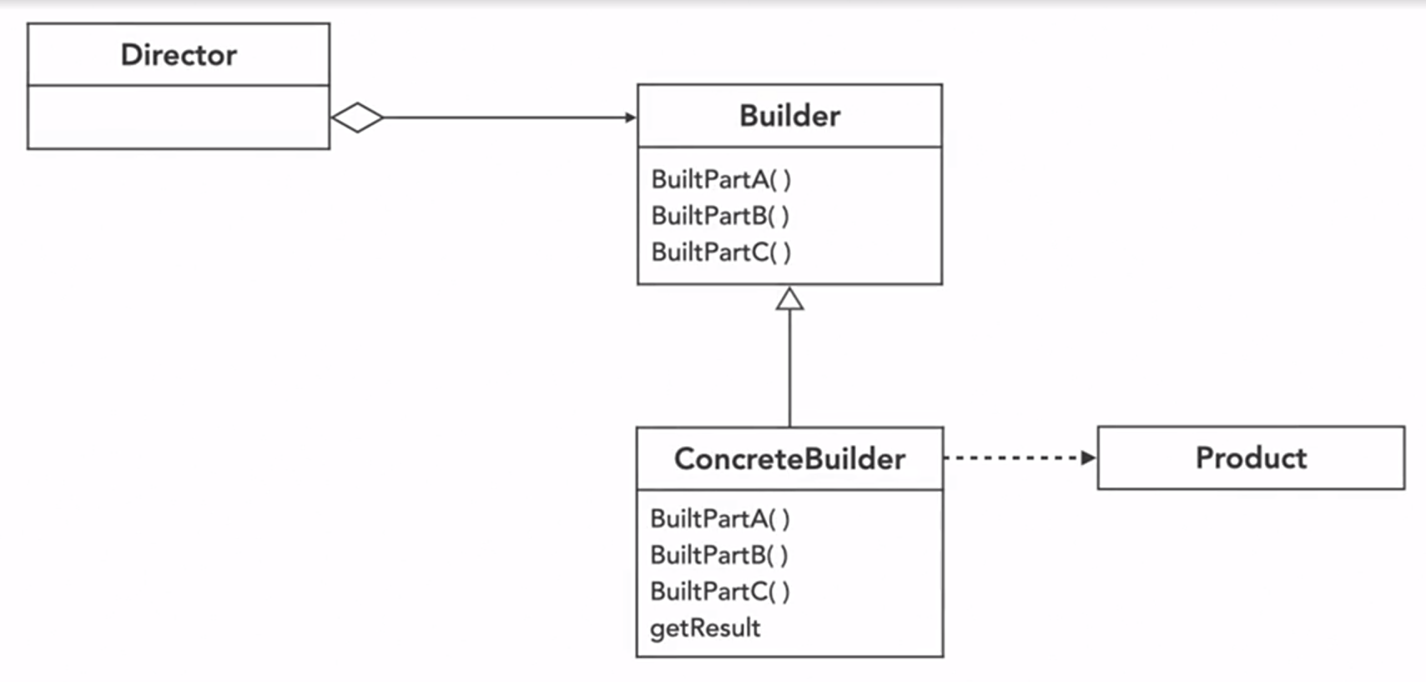

Example : combo meal at fastfood restraunts  
  
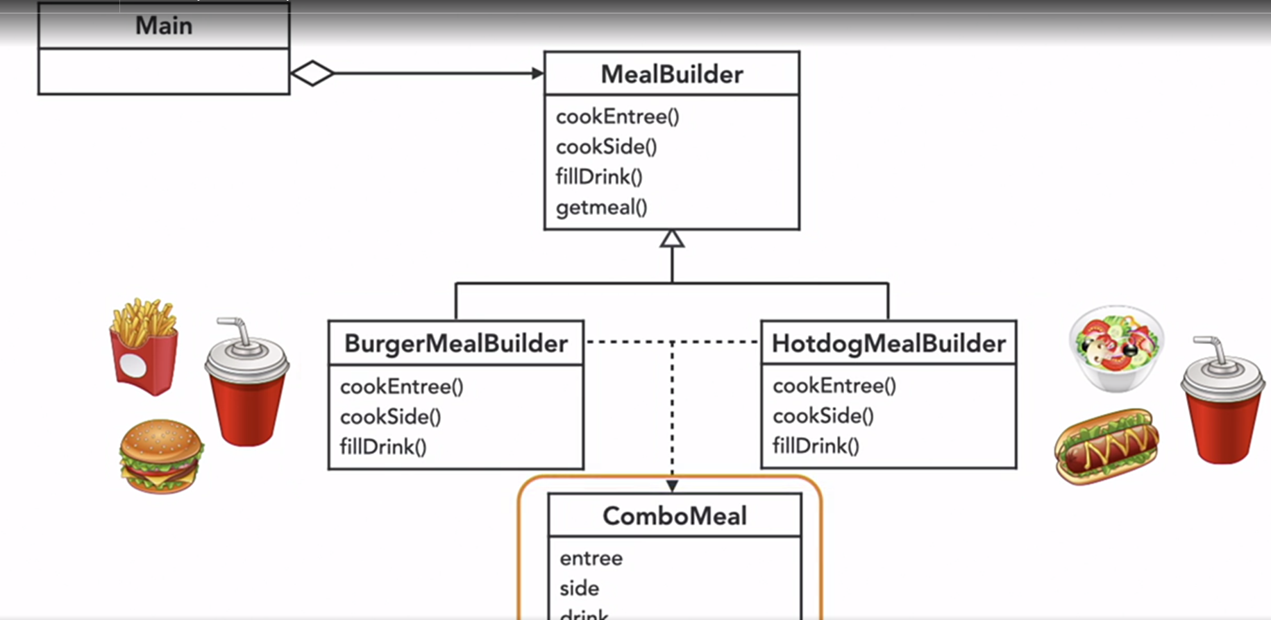



Motivation behind builder design pattern:   
  
- Some objects are simple and can be constructed in a single constructor call.  
- Other objects require a lot of ceremony to create.  
- Having an object with 10 constructor arguments is not productive.  
- Instead, opt for piecewise construction.  
- Builder provides an API to construct an object step by step.

Udemy builder example : contructing an HTML string. (good one).

Fluent-builder : where you replace void addParts() // with return type as the reference to the class that you are currently in,   
That way you can call addParts().addParts().addParts() and so on.

You can give a hint to the called to use this called function by making a static fluent builder function and keeping ther constructors as private, that way user will be forced to use fluent builder.

Note : In C++, the **operator()** function, also known as the "function call operator" or "operator parentheses," is a special function that allows objects of a class to be used as if they were a function. This feature is sometimes referred to as "operator overloading for function call."

APIs are standard contracts that define **how developers communicate with a service**, and the kind of output those developers should expect to receive back

Groovy-builder : here he is creating entire HTML language from c++ code like he has created Tag struct which has key value pair of attributes. The struct paragraph can be derived from this struct tag like struct P : Tag. Then he inherits Image struct from Tag.

## Builder : Problem

Imagine a complex object that requires laborious, step-by-step initialization of many fields and nested objects. Such initialization code is usually buried inside a monstrous constructor with lots of parameters. Or even worse: scattered all over the client code.

*The Builder pattern lets you construct complex objects step by step. The Builder doesn’t allow other objects to access the product while it’s being built.*

#### Director

You can go further and extract a series of calls to the builder steps you use to construct a product into a separate class called director. The director class defines the order in which to execute the building steps, while the builder provides the implementation for those steps. Having a director class in your program isn’t strictly necessary. You can always call the building steps in a specific order directly from the client code. However, the director class might be a good place to put various construction routines so you can reuse them across your program.

**Products** are resulting objects. Products constructed by different builders don’t have to belong to the same class hierarchy or interface.

Using the Builder pattern makes sense only when your products are quite complex and require extensive configuration.

Usually, after returning the end result to the client, a builder instance is expected to be ready to start producing another product. That's why it's a usual practice to call the reset method at the end of the `getProduct` method body. However, this behavior isn't mandatory, and you can make your builder wait for an explicit reset call from the client code before disposing of the previous result.

**class** **Application** **is**

**method** makeCar() **is**

director = **new** Director()

CarBuilder builder = **new** CarBuilder()

director.constructSportsCar(builder)

Car car = builder.getProduct()

CarManualBuilder builder = **new** CarManualBuilder()

director.constructSportsCar(builder)

// The final product is often retrieved from a builder

// object since the director isn't aware of and not

// dependent on concrete builders and products.

Manual manual = builder.getProduct()

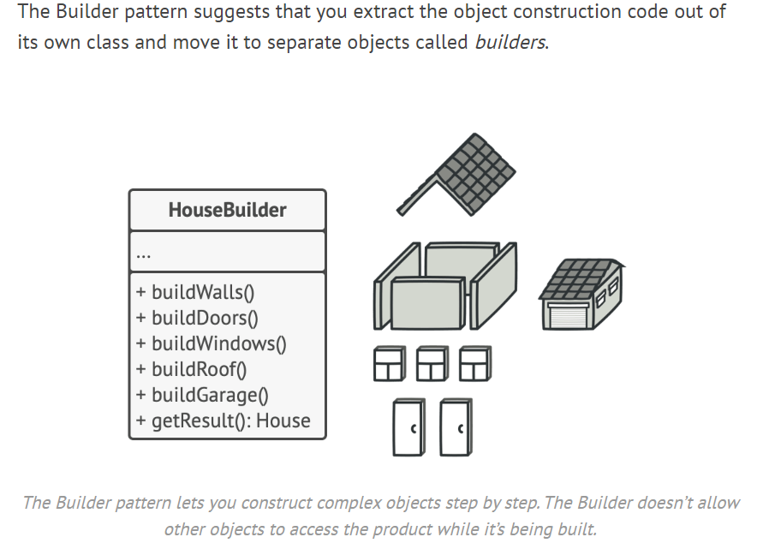

## Applicability

* **Use the Builder pattern to get rid of a “telescoping constructor”.**
* **Use the Builder pattern when you want your code to be able to create different representations of some product (for example, stone and wooden houses). :** The Builder pattern can be applied when construction of various representations of the product involves similar steps that differ only in the details.
* **Use the Builder to construct**[**Composite**](https://refactoring.guru/design-patterns/composite)**trees or other complex objects. :** The Builder pattern lets you construct products step-by-step. You could defer execution of some steps without breaking the final product. You can even call steps recursively, which comes in handy when you need to build an object tree. A builder doesn’t expose the unfinished product while running construction steps. This prevents the client code from fetching an incomplete result.
* *Single Responsibility Principle*. You can isolate complex construction code from the business logic of the product.

## How to Implement

1. Make sure that you can clearly define the common construction steps for building all available product representations. Otherwise, you won’t be able to proceed with implementing the pattern.
2. Declare these steps in the base builder interface.
3. Create a concrete builder class for each of the product representations and implement their construction steps.  
   Don’t forget about implementing a method for fetching the result of the construction. The reason why this method can’t be declared inside the builder interface is that various builders may construct products that don’t have a common interface. Therefore, you don’t know what the return type for such a method would be. However, if you’re dealing with products from a single hierarchy, the fetching method can be safely added to the base interface.
4. Think about creating a director class. It may encapsulate various ways to construct a product using the same builder object.
5. The client code creates both the builder and the director objects. Before construction starts, the client must pass a builder object to the director. Usually, the client does this only once, via parameters of the director’s class constructor. The director uses the builder object in all further construction. There’s an alternative approach, where the builder is passed to a specific product construction method of the director.
6. The construction result can be obtained directly from the director only if all products follow the same interface. Otherwise, the client should fetch the result from the builder.

**Relations with Other Patterns**

* Many designs start by using [**Factory Method**](https://refactoring.guru/design-patterns/factory-method) (less complicated and more customizable via subclasses) and evolve toward [**Abstract Factory**](https://refactoring.guru/design-patterns/abstract-factory), [**Prototype**](https://refactoring.guru/design-patterns/prototype), or [**Builder**](https://refactoring.guru/design-patterns/builder) (more flexible, but more complicated).
* [**Builder**](https://refactoring.guru/design-patterns/builder) focuses on constructing complex objects step by step. [**Abstract Factory**](https://refactoring.guru/design-patterns/abstract-factory) specializes in creating families of related objects. *Abstract Factory* returns the product immediately, whereas *Builder* lets you run some additional construction steps before fetching the product.
* You can use [**Builder**](https://refactoring.guru/design-patterns/builder) when creating complex [**Composite**](https://refactoring.guru/design-patterns/composite) trees because you can program its construction steps to work recursively.

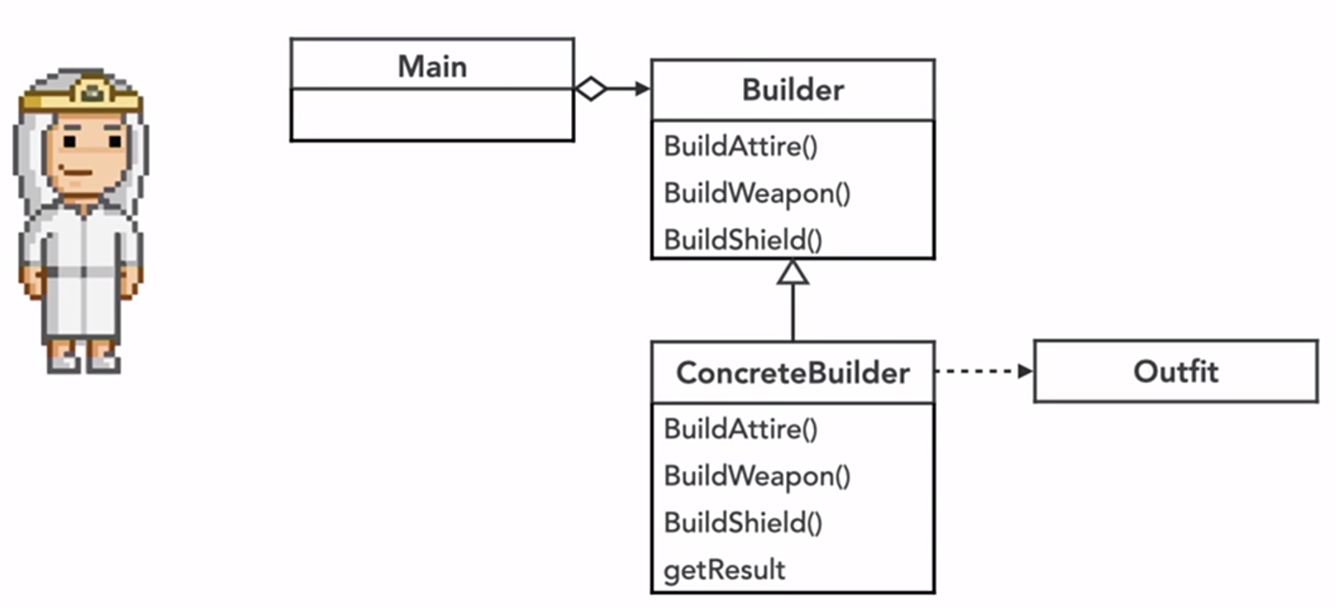

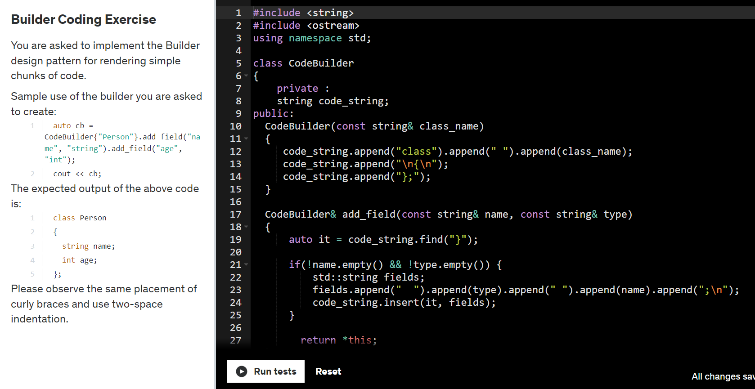

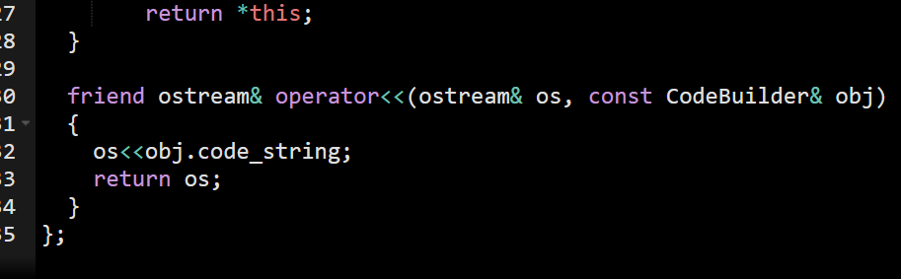

Prototype Design Pattern : When its easier to copy an existing object to fully initialize a new one.

Pros :  
You get an alternative to inheritance when dealing with configuration presets for complex objects.  
You can clone objects without coupling to their concrete classes.  
You can get rid of repeated initialization code in favor of cloning pre-built prototypes.  
You can produce complex objects more conveniently.

Motivation :

* Complicated objects aren’t designed from scratch (They reiterate existing designs)
* An existing (partially or fully constructed) design is a prototype.
* We make a copy(clone) of the prototype and customize it. (Requires deep copy support).
* We make the cloning a convenient affair ( eg. Via factory method)

A prototype is a partially or fully initialized object that you copy(clone) and make use of.

Shallow copy vs deep copy:  
Shallow copy works fine as long as you have no reference or pointer values to be copied. Also if you want two objects to refer to same object, but have different individual values to show, in that case also.

However, People usually instantiate a member variable as another class’s object in that class by taking a reference of that class, not by value. So we need to consider deep copy. For ex:  
struct Address {  
 string street;  
 string city;  
};

Struct Contact {  
 string name;  
 Address *address;  
};

When u do shallow copy, only the part having pointers gets same value, other values are different as customized.

For deep copy you have to initialize the pointer type variable with new and then assign values same as the required.

How would you provide prototype to your consumer?

* one way would be to make a globally available object called prototype which the client could customize.
* Also could make a static object inside static create_new_object() method and return a new object that is a modification of this static object. The returned value could be a unique_ptr.
* He has also used boost serialization and deserialization for clone method.

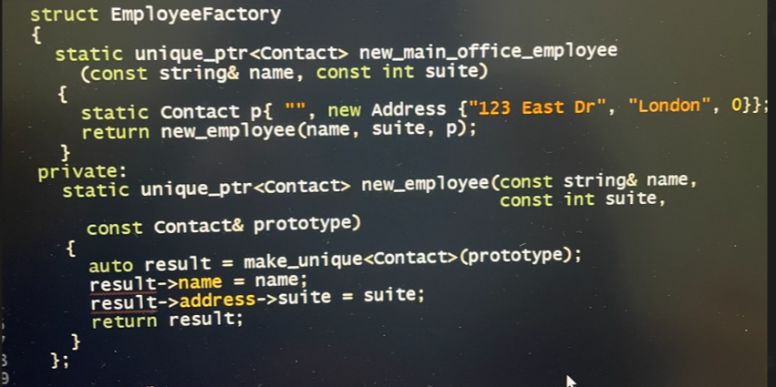

To implement a prototype design pattern, u need to partially create an object and store it somewhere.

Then clone the prototype, by either making a deep copy functionality, or by serializing and deserializing.

Then customize the resulting instance.

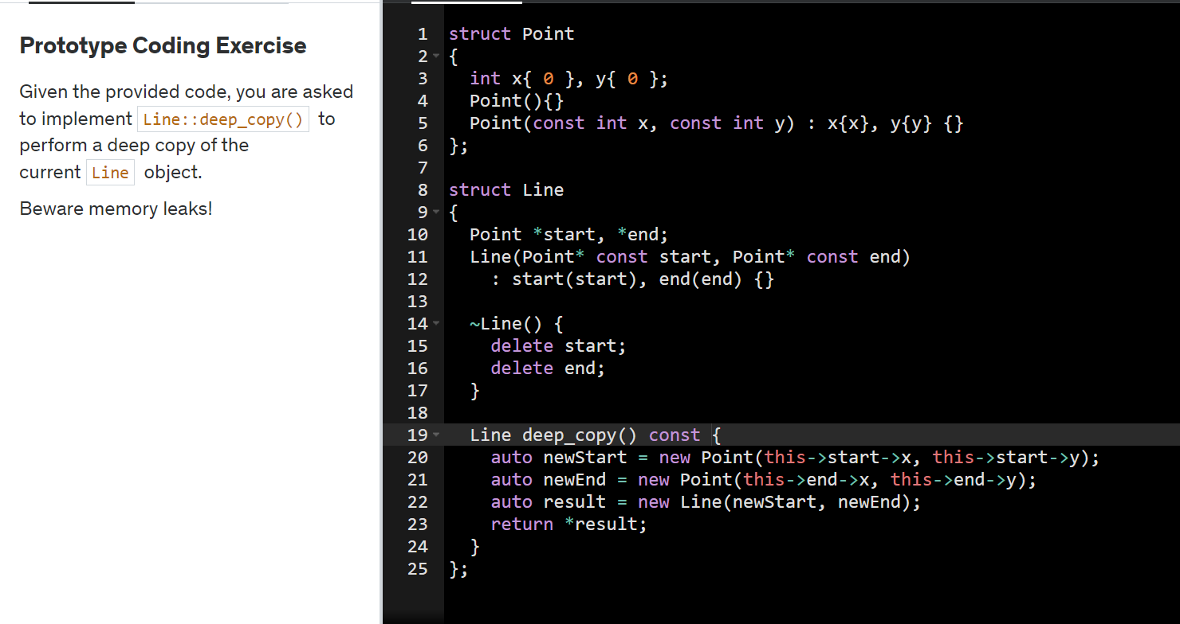

1. The **Prototype Registry** provides an easy way to access frequently-used prototypes. It stores a set of pre-built objects that are ready to be copied. The simplest prototype registry is a name → prototype hash map. However, if you need better search criteria than a simple name, you can build a much more robust version of the registry.

In the prototype constructor. A fresh object is initialized with values from the existing object.

The clone operation returns one of the Shape subclasses.

Concrete prototype. The cloning method creates a new object in one go by calling the constructor of the current class and passing the current object as the constructor's argument. Performing all the actual copying in the constructor helps to keep the result consistent: the constructor will not return a result until the new object is fully built; thus, no object can have a reference to a partially-built clone.

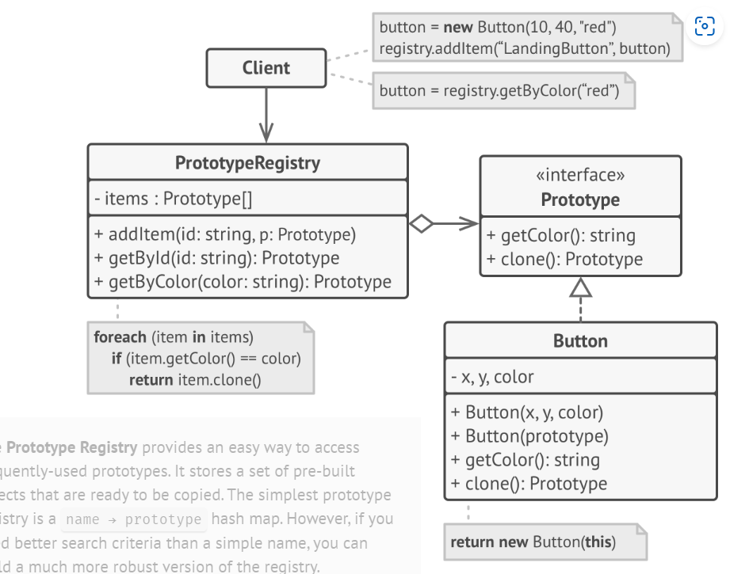

Prototype rocks because it lets you produce a copy of an object without knowing anything about its type.

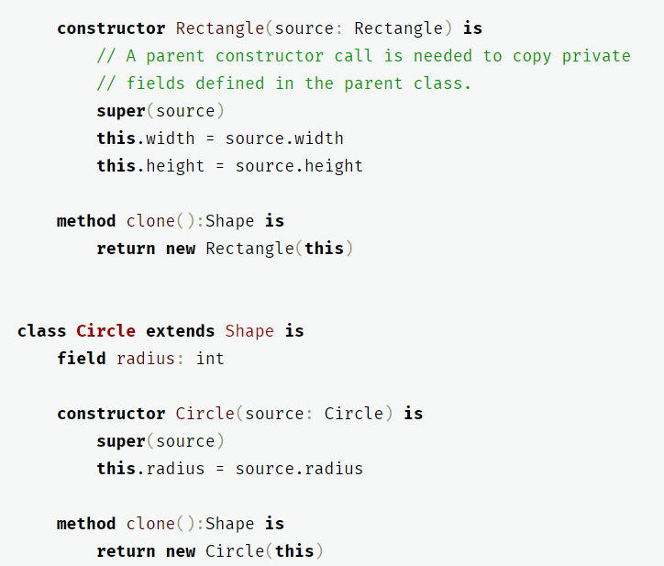

For instance, we don't know the exact elements in the shapes array. All we know is that they are all shapes. But thanks to polymorphism, when we call the clone` method on a shape the program checks its real class and runs the appropriate clone method defined in that class. That's why we get proper clones instead of a set of simple Shape objects.

If you have pointers in your properties for ex: String* name_ ,you will need to implement the Copy-Constructor to make sure you have a deep copy from the clone method.

## Applicability

* **Use the Prototype pattern when your code shouldn’t depend on the concrete classes of objects that you need to copy.**

This happens a lot when your code works with objects passed to you from 3rd-party code via some interface. The concrete classes of these objects are unknown, and you couldn’t depend on them even if you wanted to.

The Prototype pattern provides the client code with a general interface for working with all objects that support cloning. This interface makes the client code independent from the concrete classes of objects that it clones.

* **Use the pattern when you want to reduce the number of subclasses that only differ in the way they initialize their respective objects.**
* [**Prototype**](https://refactoring.guru/design-patterns/prototype) can help when you need to save copies of [**Commands**](https://refactoring.guru/design-patterns/command) into history.
* [**Prototype**](https://refactoring.guru/design-patterns/prototype) isn’t based on inheritance, so it doesn’t have its drawbacks. On the other hand, Prototype requires a complicated initialization of the cloned object. [**Factory Method**](https://refactoring.guru/design-patterns/factory-method) is based on inheritance but doesn’t require an initialization step.

## How to Implement

1. Create the prototype interface and declare the clone method in it. Or just add the method to all classes of an existing class hierarchy, if you have one.
2. A prototype class must define the alternative constructor that accepts an object of that class as an argument. The constructor must copy the values of all fields defined in the class from the passed object into the newly created instance. If you’re changing a subclass, you must call the parent constructor to let the superclass handle the cloning of its private fields.

If your programming language doesn’t support method overloading, you won’t be able to create a separate “prototype” constructor. Thus, copying the object’s data into the newly created clone will have to be performed within the clone method. Still, having this code in a regular constructor is safer because the resulting object is returned fully configured right after you call the new operator.

1. The cloning method usually consists of just one line: running a new operator with the prototypical version of the constructor. Note, that every class must explicitly override the cloning method and use its own class name along with the new operator. Otherwise, the cloning method may produce an object of a parent class.
2. Optionally, create a centralized prototype registry to store a catalog of frequently used prototypes.

You can implement the registry as a new factory class or put it in the base prototype class with a static method for fetching the prototype. This method should search for a prototype based on search criteria that the client code passes to the method. The criteria might either be a simple string tag or a complex set of search parameters. After the appropriate prototype is found, the registry should clone it and return the copy to the client.

Finally, replace the direct calls to the subclasses’ constructors with calls to the factory method of the prototype registry.

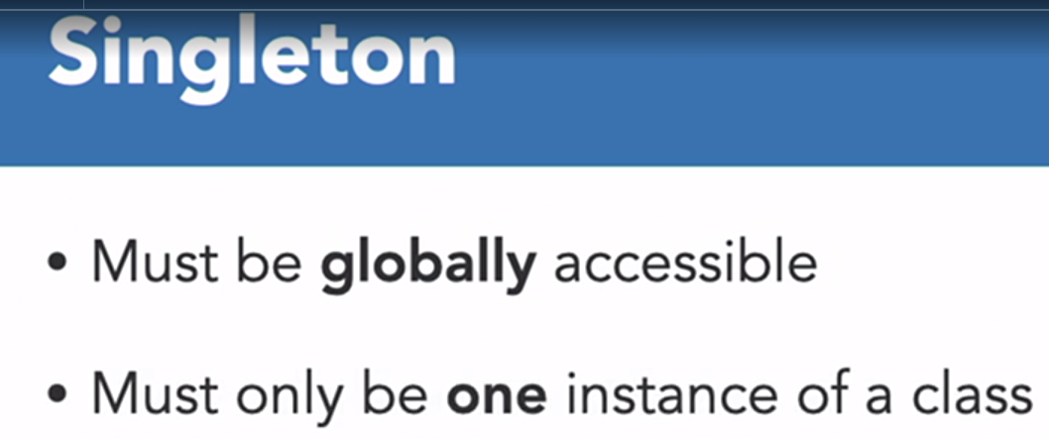

Problem with having static global variable for this purpose : The same global variable may be instantiated with the same name at two places.

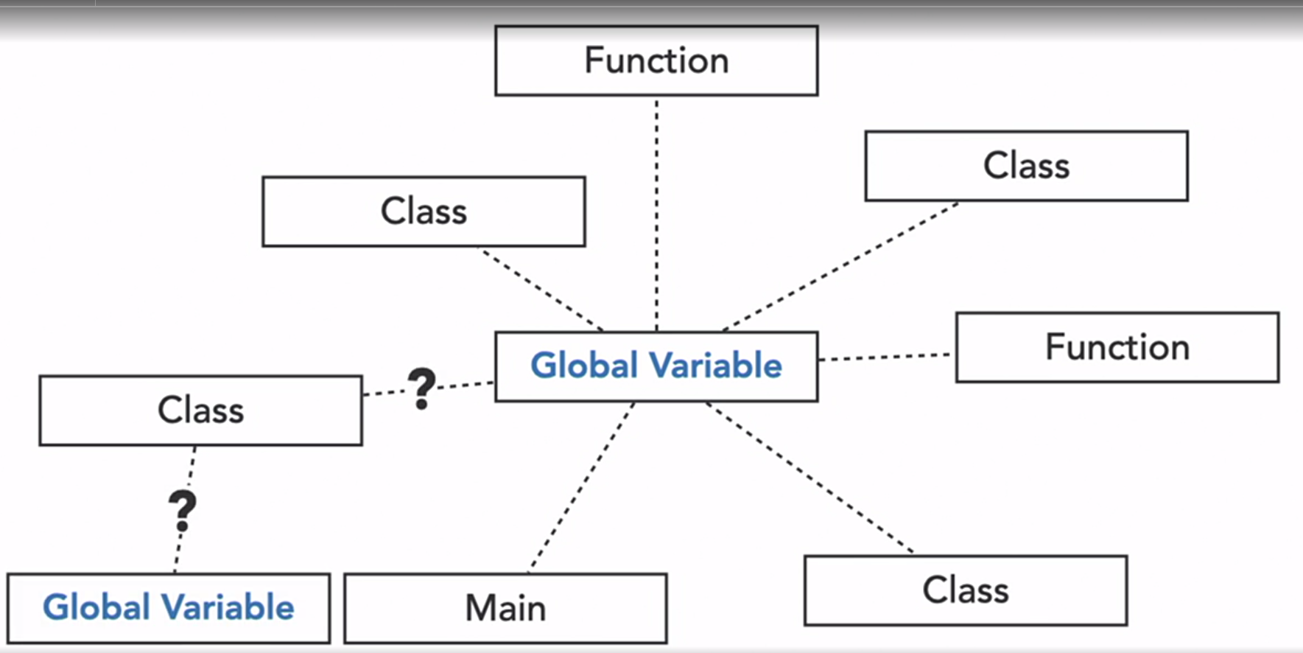

If this responsibility lies with the class, then it frees the user from the responsibility of managing such a variable.

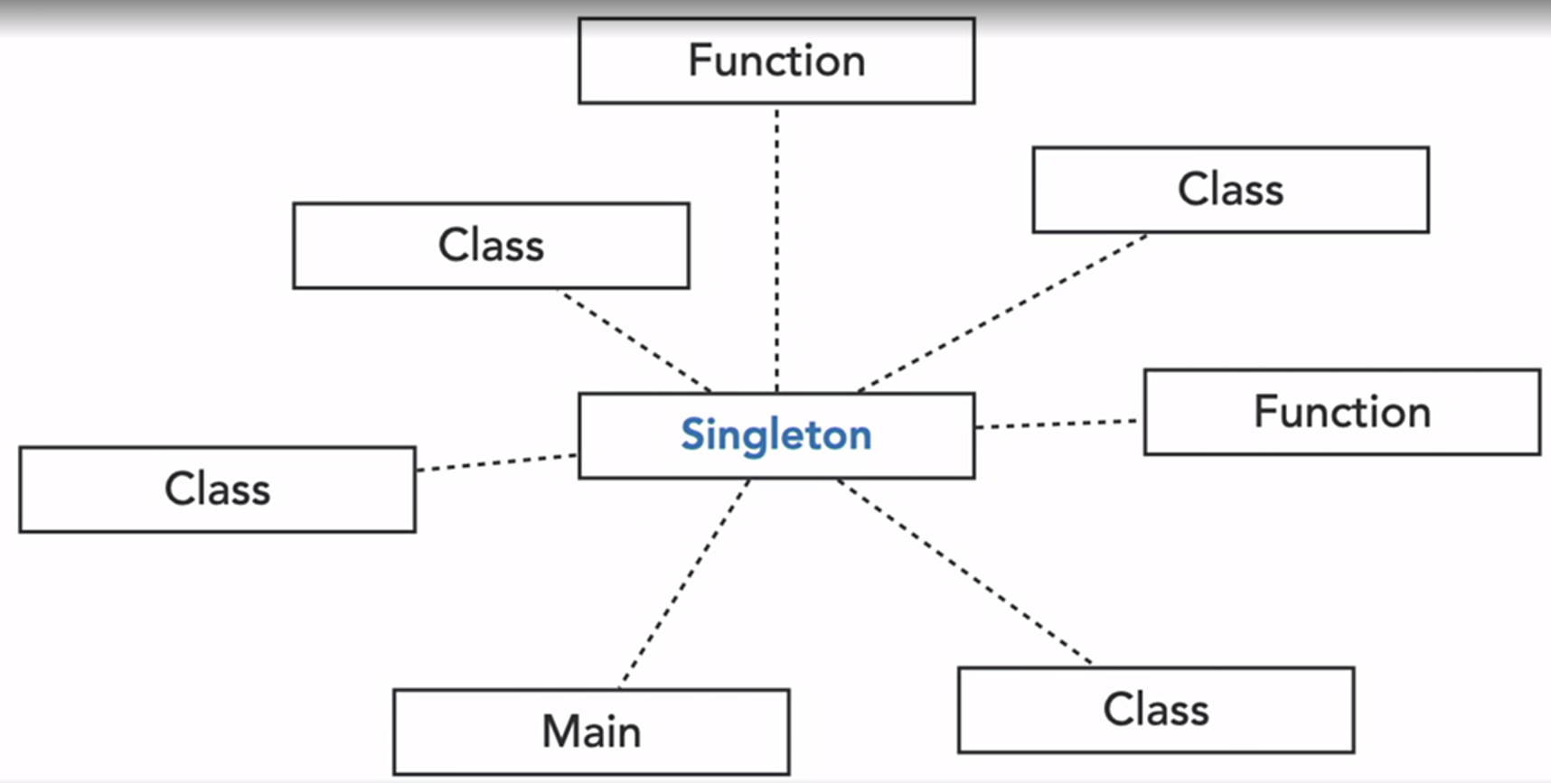

Class representation and implementation of singleton pattern : Its constructor is private which means the singleton itself is able to create singleton instance.

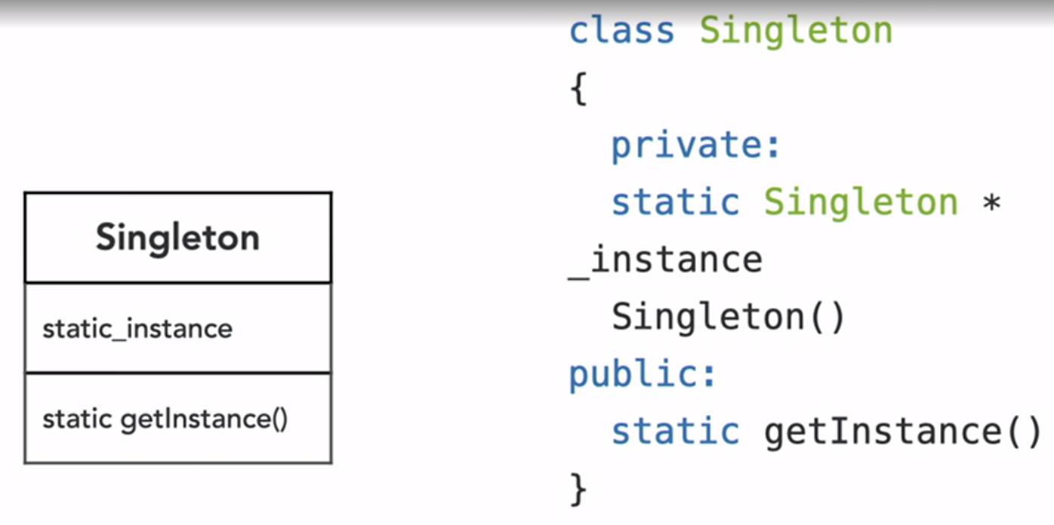

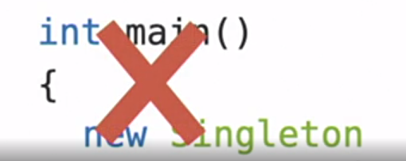 This is how we can ensure that there is only one instance of the class. Since getInstance() is a method inside class, it can access its own privare constructor. Once the instance is created, it is stored in a static variable _instance and since its static in nature, it can have only one instance.

Example :

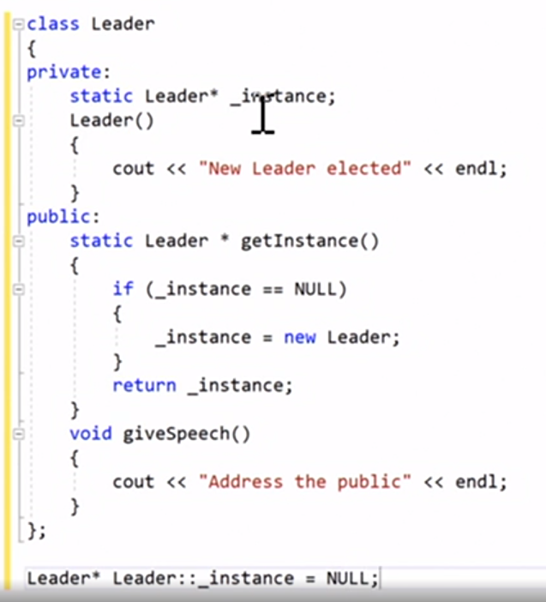

Real world use case for singleton : logging

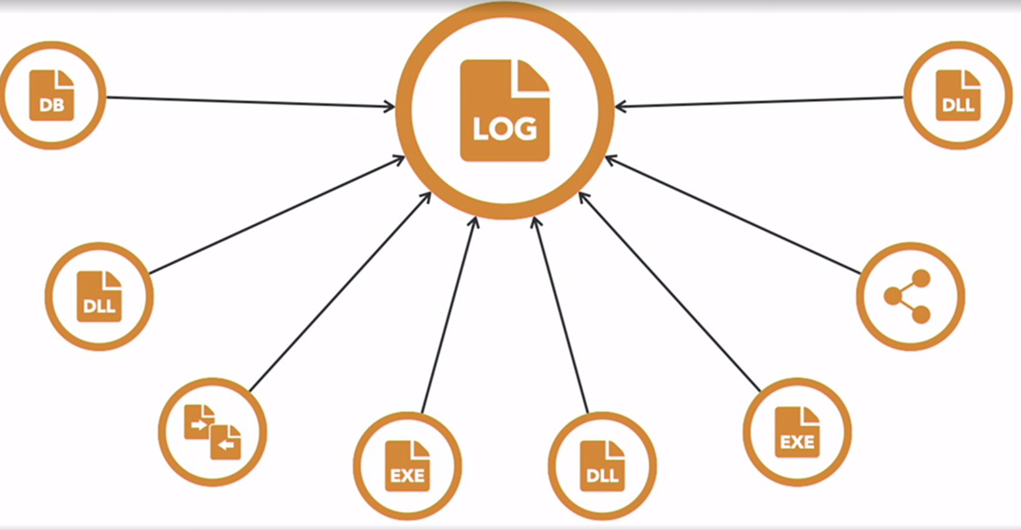

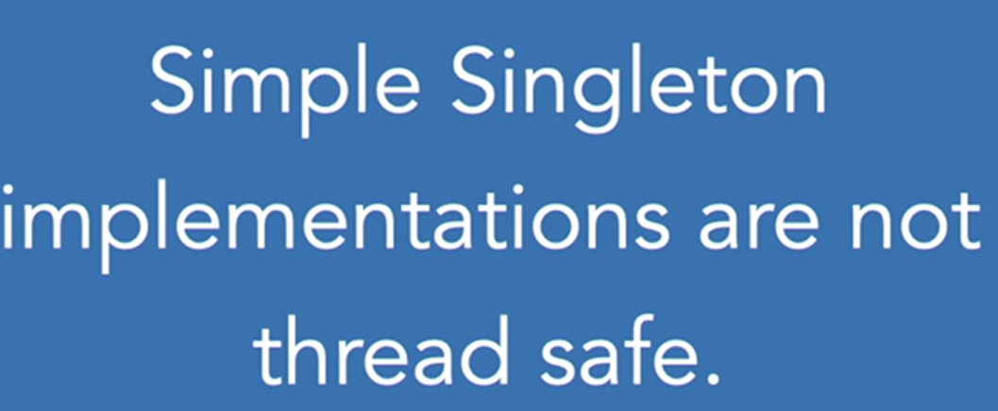

because of their global nature, this problem came.

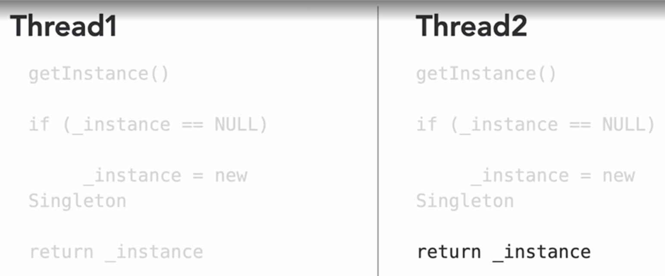

Methods to prevent this :   
Where singleton is instantiated at the beginning of the program so that there’s no competition with other threads. However, if the singleton object is expensive to instantiate and there’s a possibility that it may never be used in the program, then it’s a wasted resource.  
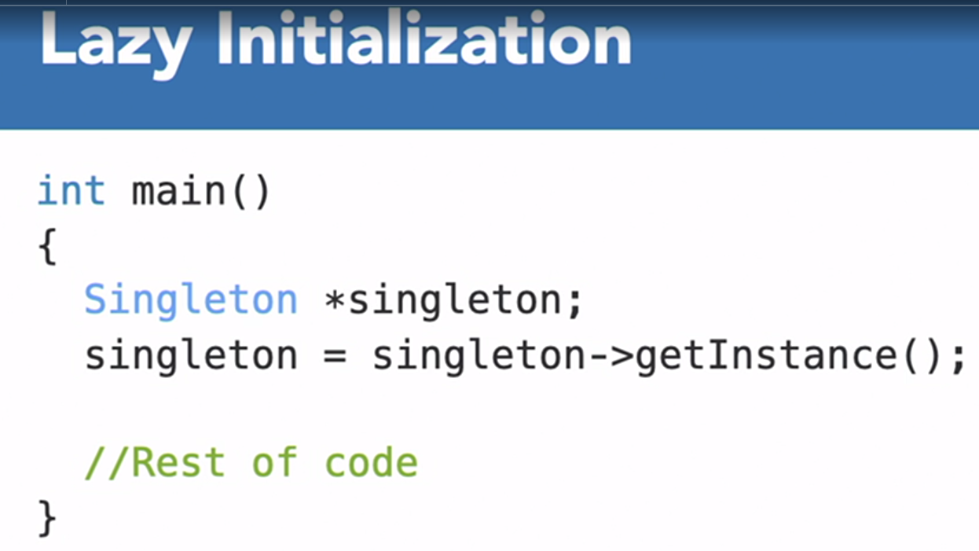

Another method to solve singleton race problem:

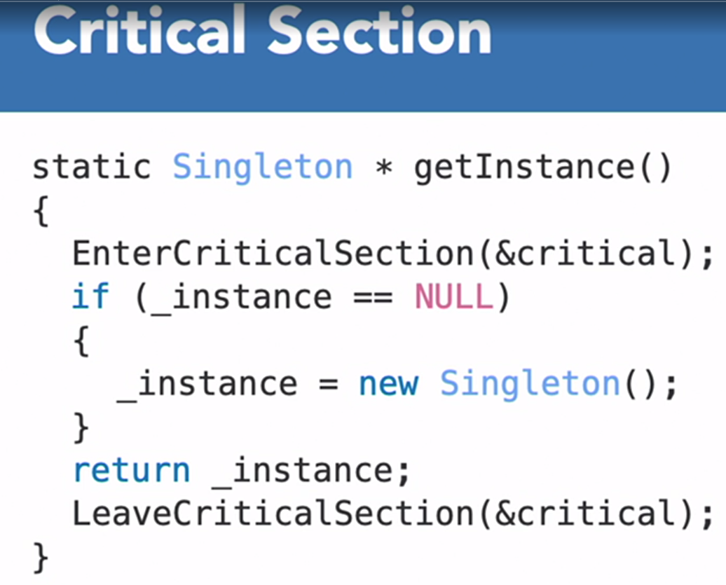

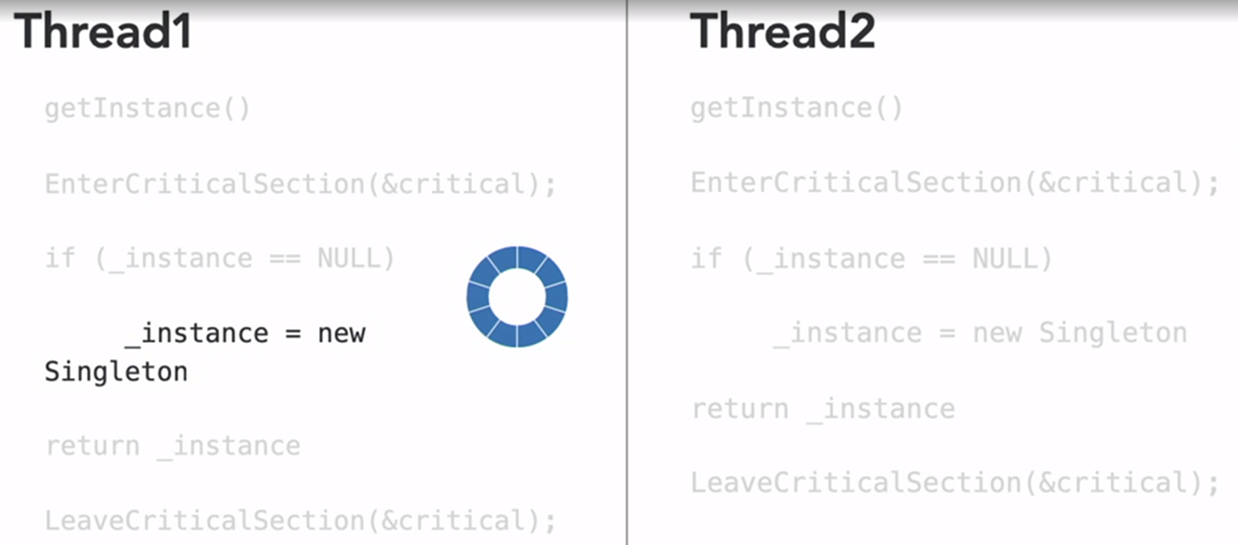



Motivation for singleton design pattern :

* For some components, it only makes sense to have one in the system, eg : database repository, object factory.
* When the constructor call is expensive. ( We do it once, We provide everyone with the same instance.)
* We want to prevent anyone creating additional copies.
* Need to take care of lazy instantiation and thread safety.

Singleton implementation In udemy includes deleting copy constructors and copy assignment operators as well in addition to keeping the constructor private.  
because of this we cannot assign singleton::getInstance() to any variable, we have to directly use it.

Problem with Singleton pattern : Testability issues. If we have a singleton database, and we want to test it, we will just be checking whether the record fetched tallies or not, as we cannot create an instance of the singleton, a proper unit test cannot be written. In this case, we are strongly tied to the values present in the database and if that changes, our test also fails.

Solution to this is have a dummy database with predictable values.

Multiton design pattern : where an enum is declared from which we can choose the type of singleton object to be created based on a key, value map.

Summary of singleton design pattern :

* Making a safe singleton is easy :
* Hide or delete the type’s constructor, copy constructors and copy assignment operators.
* Create a static method that returns a reference to a static member.
* guaranteed to be thread safe since C++11.
* Types with ‘hard’ dependencies on singleton are difficult to test
* Cannot decouple the singleton and supply a fake object.

Instead of directly using a singleton, consider depending on an extraction ( ex : an interface)

* Consider defining singleton lifetime in a dependency injection(DI) container.

